**Big Data Analytics**

**Practicals**

**Academic Year: 2022-2023**

**Index**

|  |  |  |  |
| --- | --- | --- | --- |
| **Sr. No** | **Title of the Practical** | **Page No.** | **Sign** |
| 1 | Implement Decision tree classification technique |  |  |
| 2 | Implement SVM classification technique |  |  |
| 3 | Implement Regression Model to import a data from web storage. Name the dataset and now do Logistic Regression to find out relation between variables. Also check the model is fit or not. |  |  |
| 4 | Apply Multiple Regression on a dataset having a continuous independent variable. |  |  |
| 5 | Build a Classification Model   1. Install relevant package for classification. 2. Choose classifier for classification problem. 3. Evaluate the performance of classifier. |  |  |
| 6 | Build a Clustering Model.   1. Select clustering algorithm for unsupervised learning. 2. Plot the cluster data using R/python visualizations. |  |  |
| 7 | Install, configure and run Hadoop and HDFS and explore HDFS |  |  |
| 8 | Implement an application that stores big data in Hbase / MongoDB and manipulate it using R / Python. |  |  |

## **PRACTICAL 1**

AIM: Implement Decision tree classification techniques.

THEORY:

A decision tree is a tree-based supervised learning method used to predict the output of a target variable. Supervised learning uses labeled data (data with known output variables) to make predictions with the help of regression and classification algorithms.

Supervised learning algorithms act as a supervisor for training a model with a defined output variable. It learns from simple decision rules using the various data features. Decision trees in Python can be used to solve both classification and regression problems—they are frequently used in determining odds.

Types of Decision Tree

1] Regression Tree

A Regression tree is used when the dependent variable is continuous. The value obtained by leaf nodes in the training data is the mean response of observation falling in that region. Thus, if an unseen data observation falls in that region, its prediction is made with the mean value. This means that even if the dependent variable in training data was continuous, it will only take discrete values in the test set. A regression tree follows a top-down greedy approach.

2]Classification Tree

A Classification tree is used when the dependent variable is categorical. The value obtained by leaf nodes in the training data is the mode response of observation falling in that region It follows a top-down greedy approach.

**Problem Statement:** A dataset collected in a cosmetics shop showing details of customers and whether or not they responded to a special offer to buy a new lip-stick is shown in table below. Use this dataset to build a decision tree, with Buys as the target variable, to help in buying lip-sticks in the future. Find the root node of decision tree. According to the decision tree you have made from previous training data set, what is the decision for the test data: [Age < 21, Income = Low, Gender = Female, Marital Status = Married]?

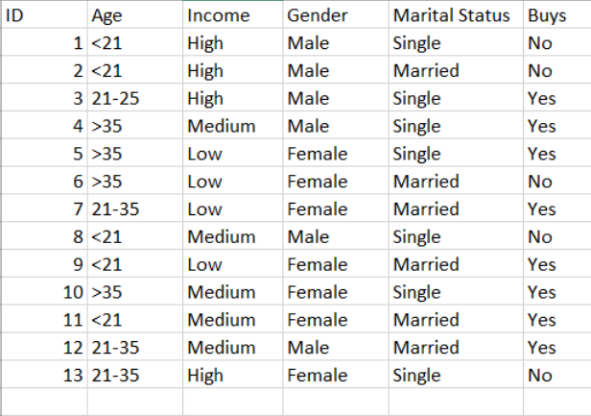

CODE:

import sklearn

import numpy as np

import pandas as pd

#importing datasets

buy = pd.read_csv('datadt.csv')

# Splitting the dataset into training and test set.

from sklearn.model_selection import train_test_split

from sklearn.tree import DecisionTreeClassifier

x_fe=['Age','Income','Gender','Marital Status']

x=buy[x_fe]

y=buy['Buys']

#Fitting Decision Tree classifier to the training set

from sklearn import preprocessing

x=x.apply(preprocessing.LabelEncoder().fit_transform)

print(x)

# Create Decision Tree classifer object

clf = DecisionTreeClassifier(criterion='entropy')

model = clf.fit(x,y)

from IPython.display import Image

from sklearn import tree

import pydotplus

dot_data = tree.export_graphviz(model, out_file=None,

feature_names=x_fe,class_names=['no', 'yes'], filled = True)

graph = pydotplus.graph_from_dot_data(dot_data)

Image(graph.create_png())

graph.write_png("dtree.png")

OUTPUT:

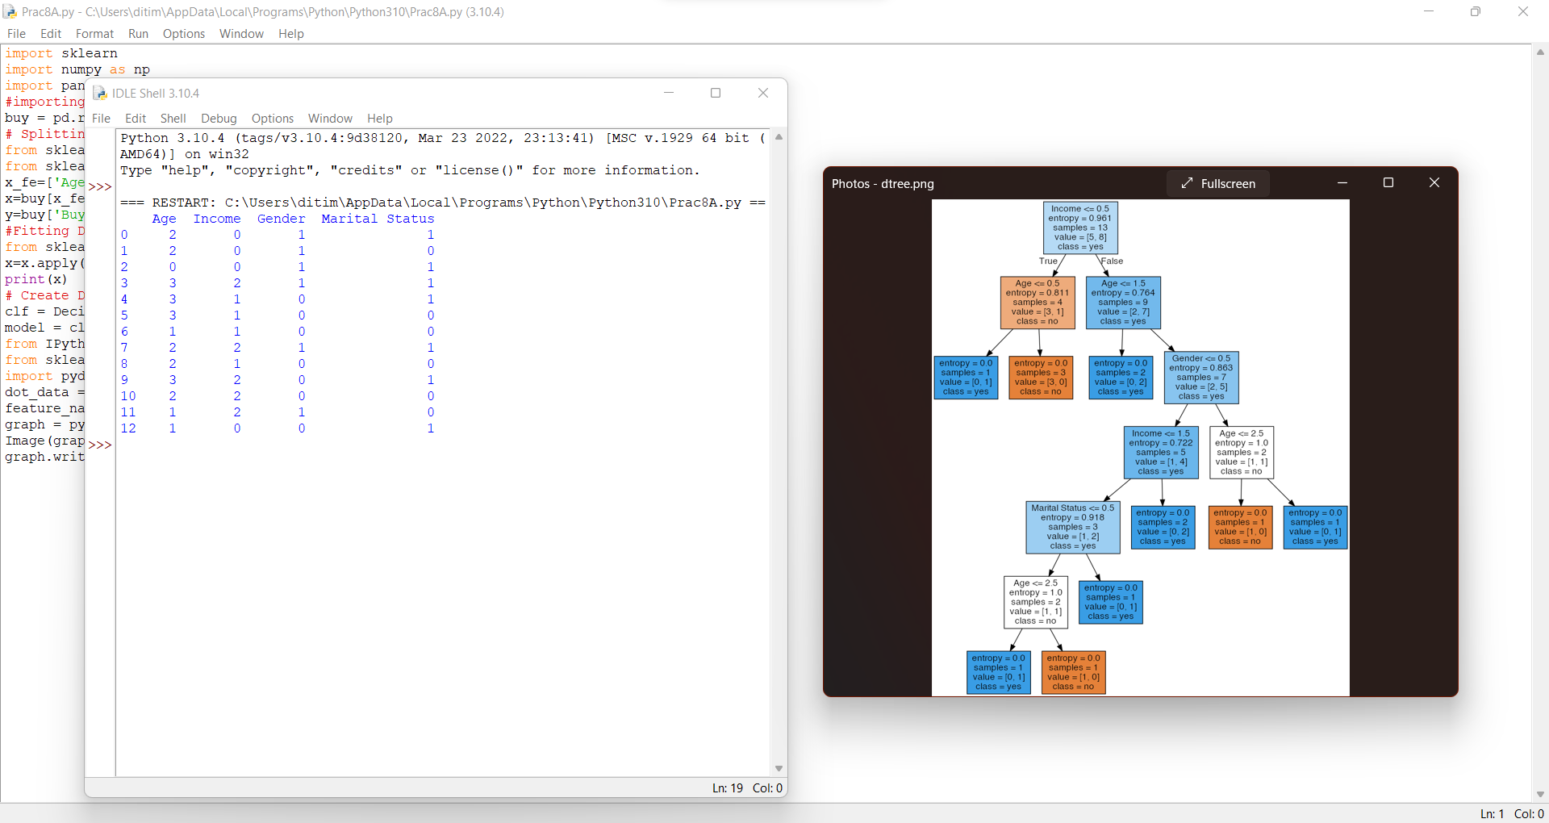

## **PRACTICAL 2**

AIM: Implement SVM classification techniques

THEORY:

A support vector machine (SVM) is a type of deep learning algorithm that performs supervised learning for the classification or regression of data groups.

In AI and machine learning, supervised learning systems provide both input and desired output data, which are labeled for classification. The classification provides a learning basis for future data processing. Support vector machines are used to sort two data groups by like classification. The algorithms draw lines (hyperplanes) to separate the groups according to patterns.

An SVM builds a learning model that assigns new examples to one group or another. By these functions, SVMs are called non-probabilistic, binary linear classifier. In probabilistic classification settings, SVMs can use methods such as Platt Scaling.

Like other supervised learning machines, an SVM requires labeled data to be trained. Groups of materials are labeled for classification. Training materials for SVMs are classified separately in different points in space and organized into clearly separated groups. After processing numerous training examples, SVMs can perform unsupervised learning.

The algorithms will try to achieve the best separation of data with the boundary around the hyperplane being maximized and even between both sides.

CODE:

from sklearn import datasets

from sklearn import metrics

from sklearn import svm

from sklearn.model_selection import train_test_split

cancer_data = datasets.load_breast_cancer()

print(cancer_data.data[5])

print(cancer_data.data.shape)

#target set

print(cancer_data.target)

cancer_data = datasets.load_breast_cancer()

X_train, X_test, y_train, y_test = train_test_split(cancer_data.data, cancer_data.target, test_size=0.4,random_state=109)

#create a classifier

cls = svm.SVC(kernel="linear")

#train the model

cls.fit(X_train,y_train)

#predict the response

pred = cls.predict(X_test)

#accuracy

print("acuracy:", metrics.accuracy_score(y_test,y_pred=pred))

#precision score

print("precision:", metrics.precision_score(y_test,y_pred=pred))

#recall score

print("recall" , metrics.recall_score(y_test,y_pred=pred))

print(metrics.classification_report(y_test, y_pred=pred))

OUTPUT:

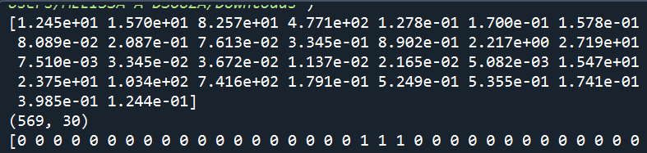

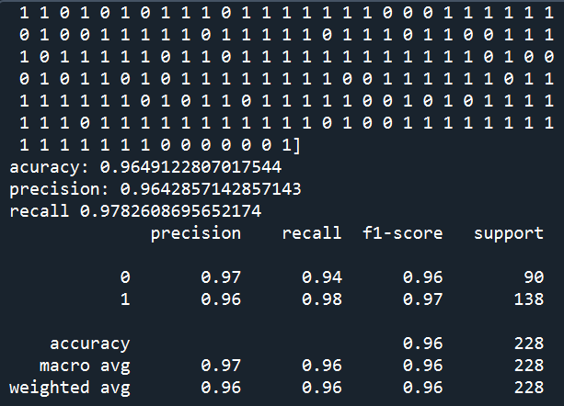

## **PRACTICAL 3**

AIM: Implement a Regression Model to import data from web Storage. Name the dataset and now do Logistic Regression to find out the relation between variables. Also, check whether the model is fit or not.

THEORY:

Regression models are used to describe relationships between variables by fitting a line to the

observed data. Regression allows you to estimate how a dependent variable changes as the

independent variable(s) change.

**Linear Regression:**

Linear regression quantifies the relationship between one or more predictor variable(s) and one

outcome variable. Linear regression is commonly used for predictive analysis and modeling.

For example, it can be used to quantify the relative impacts of age, gender, and diet (the

predictor variables) on height (the outcome variable).

**Simple linear regression formula**

The formula for a simple linear regression is:

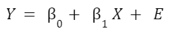

• y is the predicted value of the dependent variable (y) for any given value of the

independent variable (x).

• B0 is the intercept, the predicted value of y when the x is 0.

• B1 is the regression coefficient – how much we expect y to change as x increases.

• X is the independent variable (the variable we expect is influencing y).

• e is the error of the estimate, or how much variation there is in our estimate of the

regression coefficient.

CODE:

import matplotlib.pyplot as plt

import numpy as np

from sklearn import datasets, linear_model

from sklearn.metrics import mean_squared_error, r2_score

# Load the dataset

diabetes = datasets.load_diabetes()

# Load the diabetes dataset

diabetes_X, diabetes_y = datasets.load_diabetes(return_X_y=True)

# Description of the dataset

print(diabetes['DESCR'])

# Use only one feature

diabetes_X = diabetes_X[:, np.newaxis, 2]

# Split the data into training/testing sets

diabetes_X_train = diabetes_X[:-20]

diabetes_X_test = diabetes_X[-20:]

# Split the targets into training/testing sets

diabetes_y_train = diabetes_y[:-20]

diabetes_y_test = diabetes_y[-20:]

# Create linear regression object

regr = linear_model.LinearRegression()

# Train the model using the training sets

regr.fit(diabetes_X_train, diabetes_y_train)

# Make predictions using the testing set

diabetes_y_pred = regr.predict(diabetes_X_test)

# The coefficients

print("Coefficients: \n", regr.coef_)

# The mean squared error

print("Mean squared error: %.2f" % mean_squared_error(diabetes_y_test,

diabetes_y_pred))

# The coefficient of determination: 1 is perfect prediction

print("Coefficient of determination: %.2f" % r2_score(diabetes_y_test,

diabetes_y_pred))

# Plot outputs

plt.scatter(diabetes_X_test, diabetes_y_test, color="black")

plt.plot(diabetes_X_test, diabetes_y_pred, color="blue", linewidth=3)

plt.xticks(())

plt.yticks(())

plt.show()

OUTPUT:

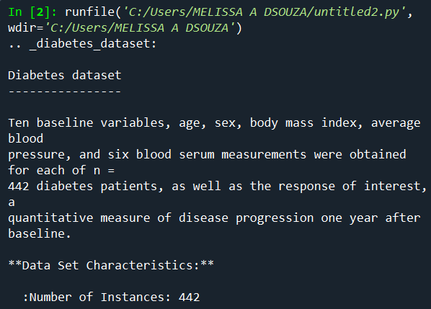

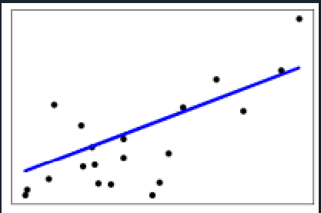

## **PRACTICAL 4**

AIM: Apply Multiple Regression on a dataset having a continuous independent variable.

THEORY:

Multiple linear regression is used to estimate the relationship between two or more independent

variables and one dependent variable. You can use multiple linear regression when you want

to know:

How strong the relationship is between two or more independent variables and one dependent

variable (e.g. how rainfall, temperature, and amount of fertilizer added affect crop growth).

The value of the dependent variable at a certain value of the independent variables (e.g. the

expected yield of a crop at certain levels of rainfall, temperature, and fertilizer addition).

**Multiple linear regression formula**

The formula for a multiple linear regression is:

$$Y= β_{0} + β_{1} X_{1}+…+β_{n}X_{n}+ E$$

• y = the predicted value of the dependent variable

• B0 = the y-intercept (value of y when all other parameters are set to 0)

• B1X1= the regression coefficient (B1) of the first independent variable (X1) (a.k.a. the

effect that increasing the value of the independent variable has on the predicted y value)

• … = do the same for however many independent variables you are testing

• BnXn = the regression coefficient of the last independent variable

• e = model error (a.k.a. how much variation there is in our estimate of y)

CODE:

In the following example, we will use multiple linear regression to predict the stock index

price (i.e., the dependent variable) of a fictitious economy by using 2 independent/input

variables:

* Interest Rate
* Unemployment Rate

Dataset:

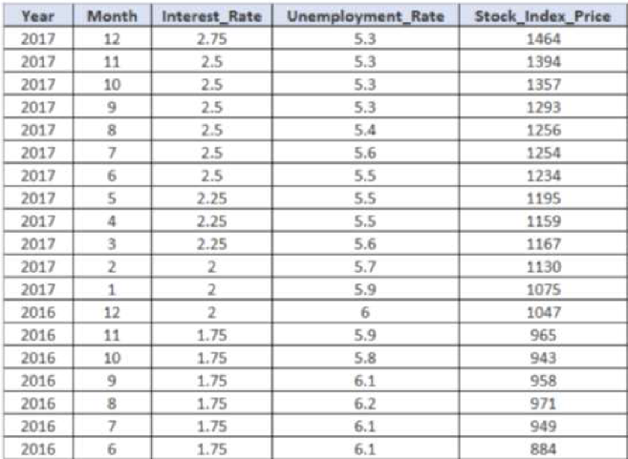

**Stock_Index_Price (dependent variable) and Interest_Rate (independent variable)**

import pandas as pd

import matplotlib.pyplot as plt

Stock_Market = {'Year':

[2017,2017,2017,2017,2017,2017,2017,2017,2017,2017,2017,2017,2016,2016,2016,2016,2016,2016,2016,2016,2016,2016,2016,2016],

'Month': [12,11,10,9,8,7,6,5,4,3,2,1,12,11,10,9,8,7,6,5,4,3,2,1],

'Interest_Rate':

[2.75,2.5,2.5,2.5,2.5,2.5,2.5,2.25,2.25,2.25,2,2,2,1.75,1.75,1.75,1.75,1.75,1.75,1.75,1.75,1.75,

1.75,1.75],

'Unemployment_Rate':

[5.3,5.3,5.3,5.3,5.4,5.6,5.5,5.5,5.5,5.6,5.7,5.9,6,5.9,5.8,6.1,6.2,6.1,6.1,6.1,5.9,6.2,6.2,6.1],

'Stock_Index_Price':

[1464,1394,1357,1293,1256,1254,1234,1195,1159,1167,1130,1075,1047,965,943,958,971,949,884,866,876,822,704,719]

}

df =pd.DataFrame(Stock_Market,columns=['Year','Month','Interest_Rate','Unemployment_Rate','Stock_Index_Price'])

plt.scatter(df['Interest_Rate'], df['Stock_Index_Price'], color='red')

plt.title('Stock Index Price Vs Interest Rate', fontsize=14)

plt.xlabel('Interest Rate', fontsize=14)

plt.ylabel('Stock Index Price', fontsize=14)

plt.grid(True)

plt.show()

OUTPUT:

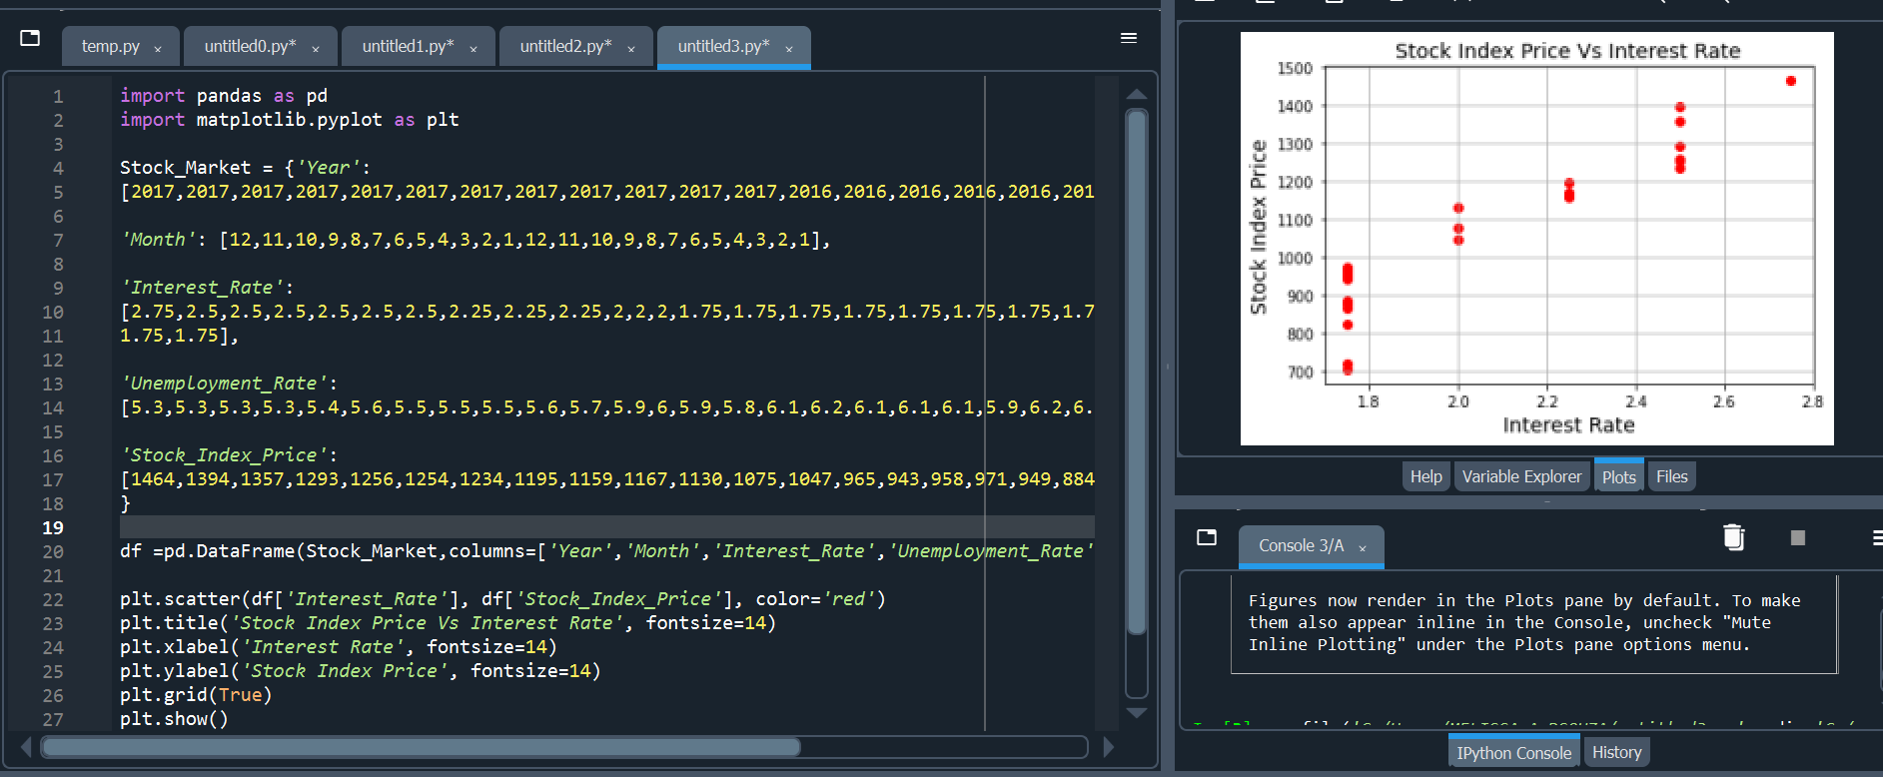

**Stock_Index_Price and the Unemployment_Rate:**

import pandas as pd

import matplotlib.pyplot as plt

Stock_Market = {'Year':

[2017,2017,2017,2017,2017,2017,2017,2017,2017,2017,2017,2017,2016,2016,2016,2016,

2016,2016,2016,2016,2016,2016,2016,2016],

'Month': [12, 11,10,9,8,7,6,5,4,3,2,1,12,11,10,9,8,7,6,5,4,3,2,1],

'Interest_Rate':

[2.75,2.5,2.5,2.5,2.5,2.5,2.5,2.25,2.25,2.25,2,2,2,1.75,1.75,1.75,1.75,1.75,1.75,1.75,

1.75,1.75,1.75,1.75],

'Unemployment_Rate':

[5.3,5.3,5.3,5.3,5.4,5.6,5.5,5.5,5.5,5.6,5.7,5.9,6,5.9,5.8,6.1,6.2,6.1,6.1,6.1,5.9,6.2,

6.2,6.1],

'Stock_Index_Price':

[1464,1394,1357,1293,1256,1254,1234,1195,1159,1167,1130,1075,1047,965,943,958,971,949,

884,866,876,822,704,719]

}

df =pd.DataFrame(Stock_Market,columns=['Year','Month','Interest_Rate',

'Unemployment_Rate','Stock_Index_Price'])

plt.scatter(df['Unemployment_Rate'], df['Stock_Index_Price'], color='blue')

plt.title('Stock Index Price Vs Unemployment Rate', fontsize=14)

plt.xlabel('Unemployment Rate', fontsize=14)

plt.ylabel('Stock Index Price', fontsize=14)

plt.grid(True)

plt.show()

OUTPUT:

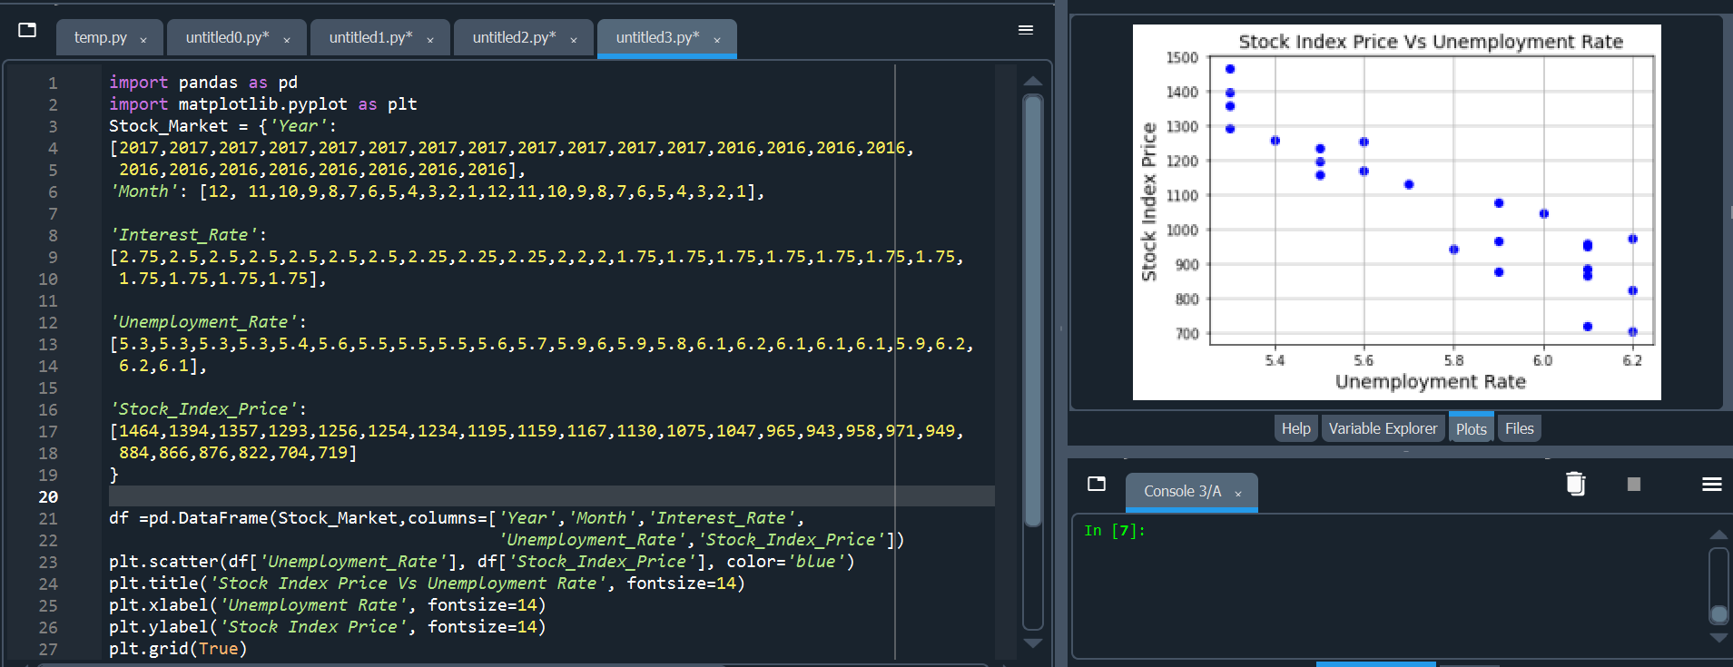

## **PRACTICAL 5 \***

AIM: Build a classification model:

1. Install relevant package for classification.
2. Choose classifier for classification problem.
3. Evaluate the performance of classifier.

THEORY:

Classification is defined as the process of recognition, understanding, and grouping of objects and ideas into preset categories a.k.a “sub-populations.” With the help of these pre-categorized training datasets, classification in machine learning programs leverage a wide range of algorithms to classify future datasets into respective and relevant categories.

Based on training data, the Classification algorithm is a Supervised Learning technique used to categorize new observations. In classification, a program uses the dataset or observations provided to learn how to categorize new observations into various classes or groups.

For instance, 0 or 1, red or blue, yes or no, spam or not spam, etc. Targets, labels, or categories can all be used to describe classes. The Classification algorithm uses labeled input data because it is a supervised learning technique and comprises input and output information. A discrete output function (y) is transferred to an input variable in the classification process (x).

Types of Classification algorithms

1. Logistic Regression:– It is one of the linear models which can be used for classification. It uses the sigmoid function to calculate the probability of a certain event occurring. It is an ideal method for the classification of binary variables.
2. K-Nearest Neighbours (kNN):– It uses distance metrics like Euclidean distance, Manhattan distance, etc. to calculate the distance of one data point from every other data point. To classify the output, it takes a majority vote from k nearest neighbours of each data point.
3. Decision Trees:– It is a non-linear model that overcomes a few of the drawbacks of linear algorithms like Logistic regression. It builds the classification model in the form of a tree structure that includes nodes and leaves. This algorithm involves multiple if else statements which help in breaking down the structure into smaller structures and eventually providing the final outcome. It can be used for regression as well as classification problems.
4. Random Forest:– It is an ensemble learning method that involves multiple decision trees to predict the outcome of the target variable. Each decision tree provides its own outcome. In the case of the classification problem, it takes the majority vote of these multiple decision trees to classify the final outcome. In the case of the regression problem, it takes the average of the values predicted by the decision trees.
5. Naïve Bayes:– It is an algorithm that is based upon Bayes’ theorem. It assumes that any particular feature is independent of the inclusion of other features. i.e., They are not correlated to one another. It generally does not work well with complex data due to this assumption as in most of the data sets there exists some kind of relationship between the features.
6. Support Vector Machine:– It represents the data points in multi-dimensional space. These data points are then segregated into classes with the help of hyperplanes. It plots an n-dimensional space for the n number of features in the dataset and then tries to create the hyperplanes such that it divides the data points with maximum margin.

CODE & OUTPUT:

import numpy as np

import pandas as pd

import matplotlib.pyplot as plt

fruits=pd.read_table('fruit_data_with_colors.txt')

fruits.head()

print(fruits['fruit_name'].unique())

print(fruits.shape)

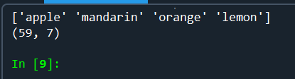

Steps to fit dataset in training and testing datasets

**Classification**

* Logistic Regression

CODE:

import matplotlib.pyplot as plt

import numpy as np

from sklearn import datasets, linear_model

from sklearn.linear_model import LogisticRegression

from sklearn.metrics import mean_squared_error, r2_score

from sklearn.model_selection import train_test_split

diabetes = datasets.load_diabetes()

diabetes_X, diabetes_y = datasets.load_diabetes(return_X_y=True)

print(diabetes['DESCR'])

diabetes_X = diabetes_X[:, np.newaxis, 2]

diabetes_X_train = diabetes_X[:-20]

diabetes_X_test = diabetes_X[-20:]

diabetes_y_train = diabetes_y[:-20]

diabetes_y_test = diabetes_y[-20:]

regr=LogisticRegression()

regr.fit(diabetes_X_train, diabetes_y_train)

diabetes_Y_pred= regr.predict(diabetes_X_test)

print ("Coefficient:\n",regr.coef_)

print('Accuracy of Logistic regression classifier on training set: (%s)'%format(regr.score(diabetes_X_train, diabetes_y_train)))

print('Accuracy of Logistic regression classifier on testing set: (%s)'%format(regr.score(diabetes_X_test, diabetes_y_test)))

OUTPUT:

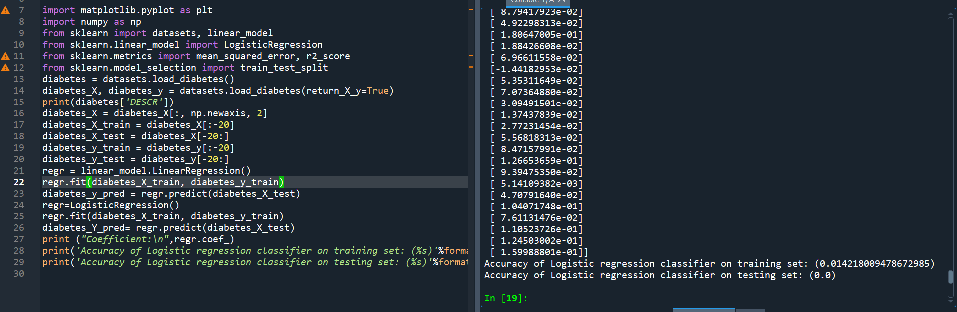

* Decision Tree

CODE:

import matplotlib.pyplot as plt

import numpy as np

from sklearn import datasets, linear_model

from sklearn.metrics import mean_squared_error, r2_score

from sklearn.tree import DecisionTreeClassifier

diabetes = datasets.load_diabetes()

diabetes_X, diabetes_y = datasets.load_diabetes(return_X_y=True)

print(diabetes['DESCR'])

diabetes_X = diabetes_X[:, np.newaxis, 2]

diabetes_X_train = diabetes_X[:-20]

diabetes_X_test = diabetes_X[-20:]

diabetes_y_train = diabetes_y[:-20]

diabetes_y_test = diabetes_y[-20:]

regr=DecisionTreeClassifier()

regr.fit(diabetes_X_train, diabetes_y_train)

diabetes_Y_pred= regr.predict(diabetes_X_test)

print('Accuracy of DecisionTreeClassifier on training set: (%s)'%format(regr.score(diabetes_X_train, diabetes_y_train)))

print('Accuracy of DecisionTreeClassifier on testing set: (%s)'%format(regr.score(diabetes_X_test, diabetes_y_test)))

OUTPUT:

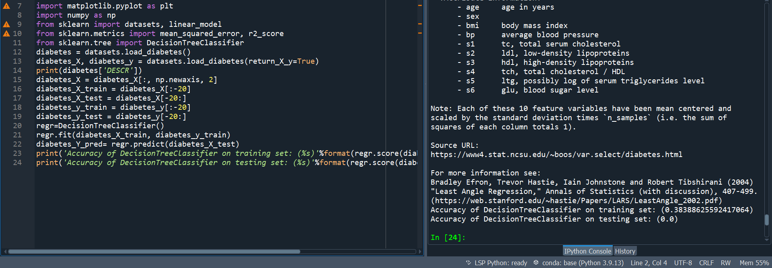

Importing Numpy and pandas for classification, further using different models

Visualization of fruit data using seaborn library

CODE:

import numpy as np

import pandas as pd

import matplotlib.pyplot as plt

fruits=pd.read_table('fruit_data_with_colors.txt')

print(fruits.groupby('fruit_name').size())

import seaborn as sns

sns.countplot(fruits['fruit_name'],label="Count")

plt.show()

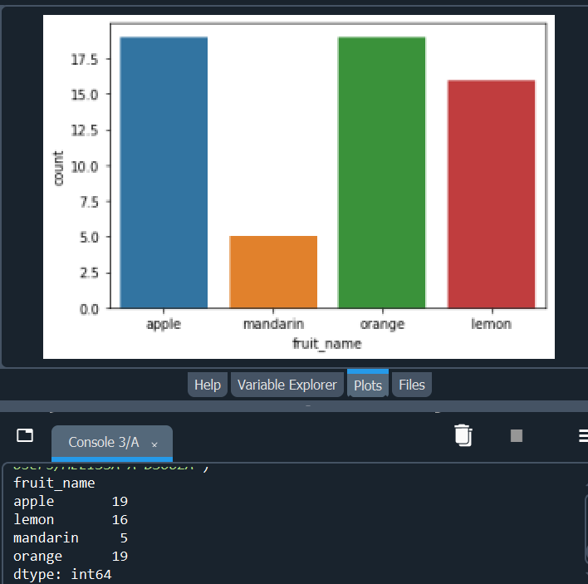

## **PRACTICAL 6**

AIM: Build a Clustering Model.

1. Clustering algorithms for unsupervised classification.
2. Plot the cluster data using R visualizations.

THEORY:

Clustering or cluster analysis is a machine learning technique, which groups the unlabelled dataset. It can be defined as ***"A way of grouping the data points into different clusters, consisting of similar data points. The objects with the possible similarities remain in a group that has less or no similarities with another group."***

It does it by finding some similar patterns in the unlabelled dataset such as shape, size, color, behavior, etc., and divides them as per the presence and absence of those similar patterns.

It is an [unsupervised learning](https://www.javatpoint.com/unsupervised-machine-learning) method, hence no supervision is provided to the algorithm, and it deals with the unlabeled dataset.

Types of Clustering algorithms

1. K-Means Clustering:– It initializes a pre-defined number of k clusters and uses distance metrics to calculate the distance of each data point from the centroid of each cluster. It assigns the data points into one of the k clusters based on its distance.
2. Agglomerative Hierarchical Clustering (Bottom-Up Approach):– It considers each data point as a cluster and merges these data points on the basis of distance metric and the criterion which is used for linking these clusters.
3. Divisive Hierarchical Clustering (Top-Down Approach):– It initializes with all the data points as one cluster and splits these data points on the basis of distance metric and the criterion. Agglomerative and Divisive clustering can be represented as a dendrogram and the number of clusters to be selected by referring to the same.
4. DBSCAN (Density-based Spatial Clustering of Applications with Noise):– It is a density-based clustering method. Algorithms like K-Means work well on the clusters that are fairly separated and create clusters that are spherical in shape. DBSCAN is used when the data is in arbitrary shape and it is also less sensitive to the outliers. It groups the data points that have many neighbouring data points within a certain radius.
5. OPTICS (Ordering Points to Identify Clustering Structure):– It is another type of density-based clustering method and it is similar in process to DBSCAN except that it considers a few more parameters. But it is more computationally complex than DBSCAN. Also, it does not separate the data points into clusters, but it creates a reachability plot which can help in the interpretation of creating clusters.

**K-means Clustering**

CODE:

from numpy import unique

from numpy import where

from sklearn.datasets import make_classification

from sklearn.cluster import KMeans

from matplotlib import pyplot

X, _ = make_classification(n_samples=1000, n_features=2, n_informative=2, n_redundant=0, n_clusters_per_class=1,random_state=4)

model=KMeans(n_clusters=2)

model.fit(X)

yhat=model.predict(X)

clusters=unique(yhat)

for cluster in clusters:

row_ix = where(yhat == cluster)

pyplot.scatter(X[row_ix,0],X[row_ix,1])

pyplot.show()

OUTPUT:

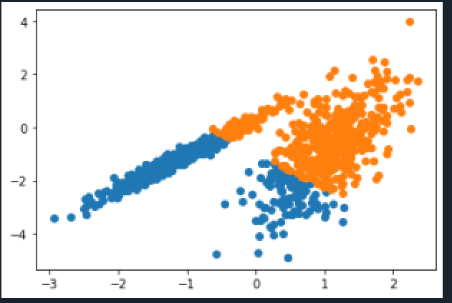

## **PRACTICAL 7 \***

AIM: Install, configure and run Hadoop and HDFS and explore HDFS.

Step 1: Download Java from Oracle website

Search for Java SE Development Kit 8 download.

JDK is downloaded.

Step 2: Download Hadoop for the local system.

Step 3: Install Java

Step 4: Setting Environment Variables for Java

Windows -> Settings -> System -> Environment Variables for system -> Edit the system environment variables

Step 5: Java Version Checking

Go to Command Prompt

Step 6: Install Hadoop to Local System

Unzip Hadoop set-up file

Step 7: Configuration of Hadoop

Go to C:\hadoop\etc\hadoop

Step 8: Verification of Hadoop Installation

Go to command prompt.

Type: *hdfs namenode -format*

If set of files pop up on the terminal, then Hadoop is successfully installed.

x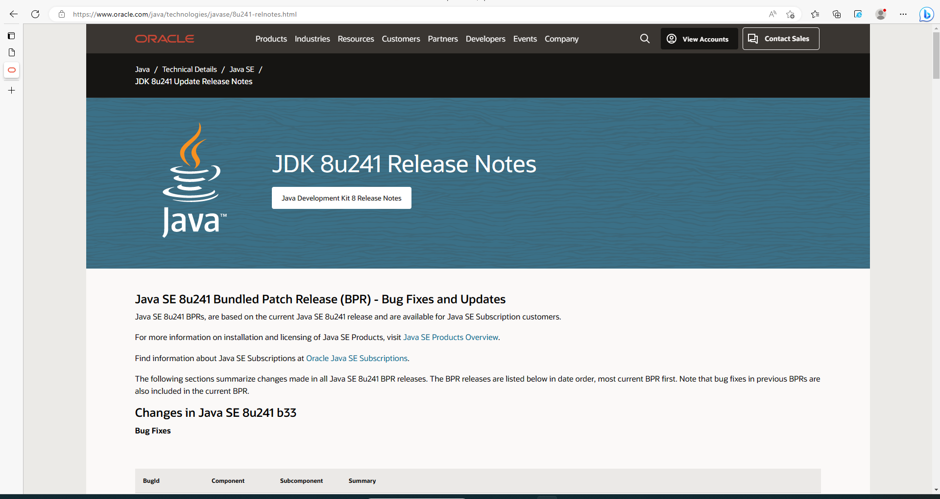

Set environment variable for java 8.1.0_241

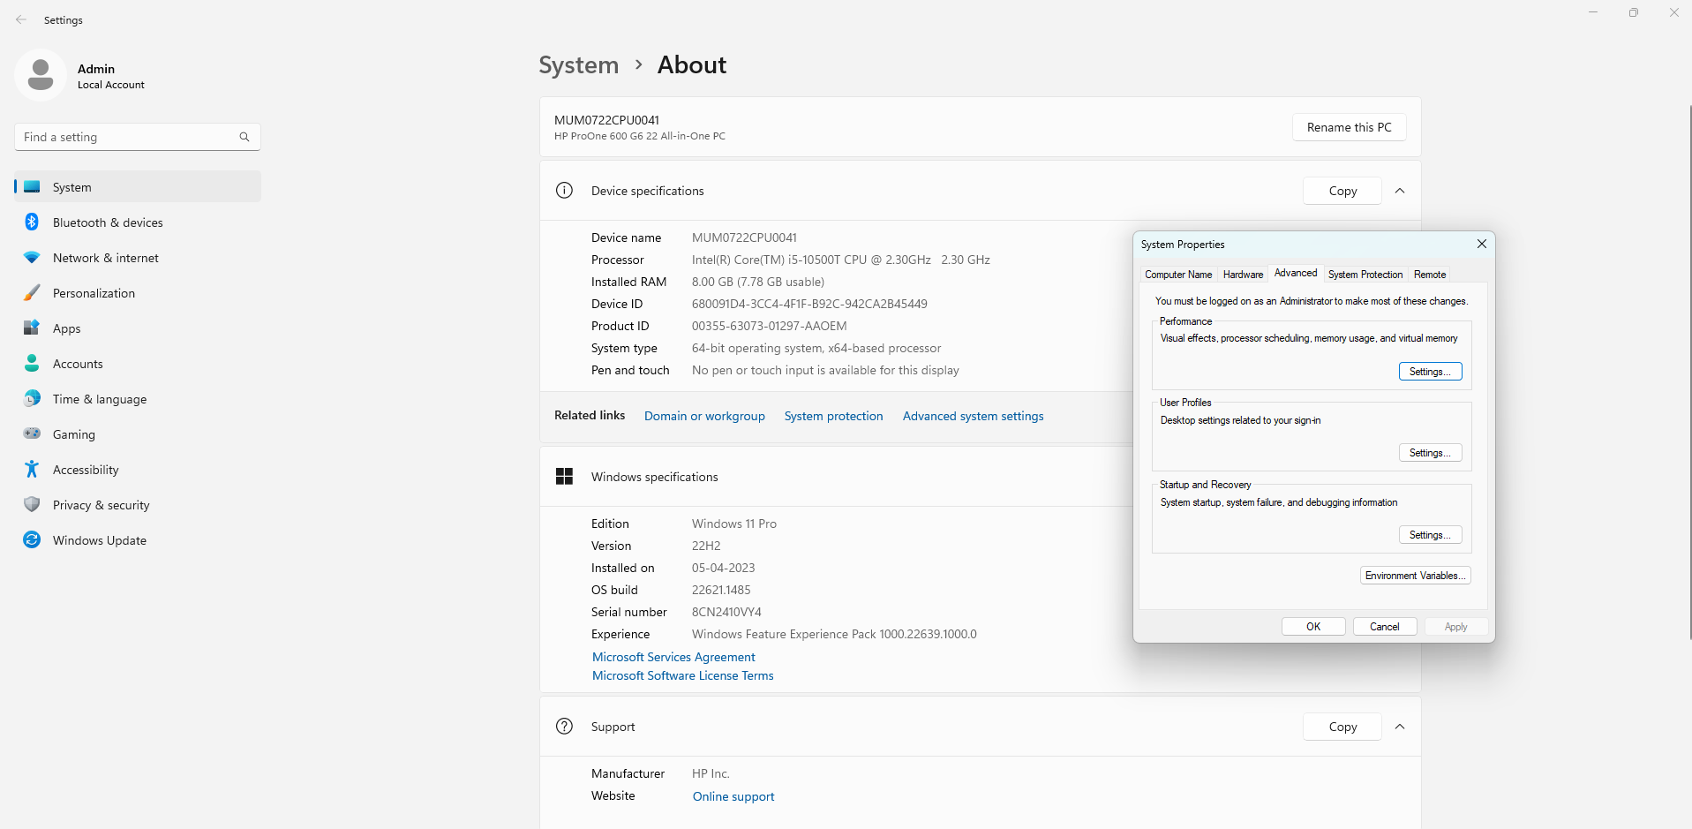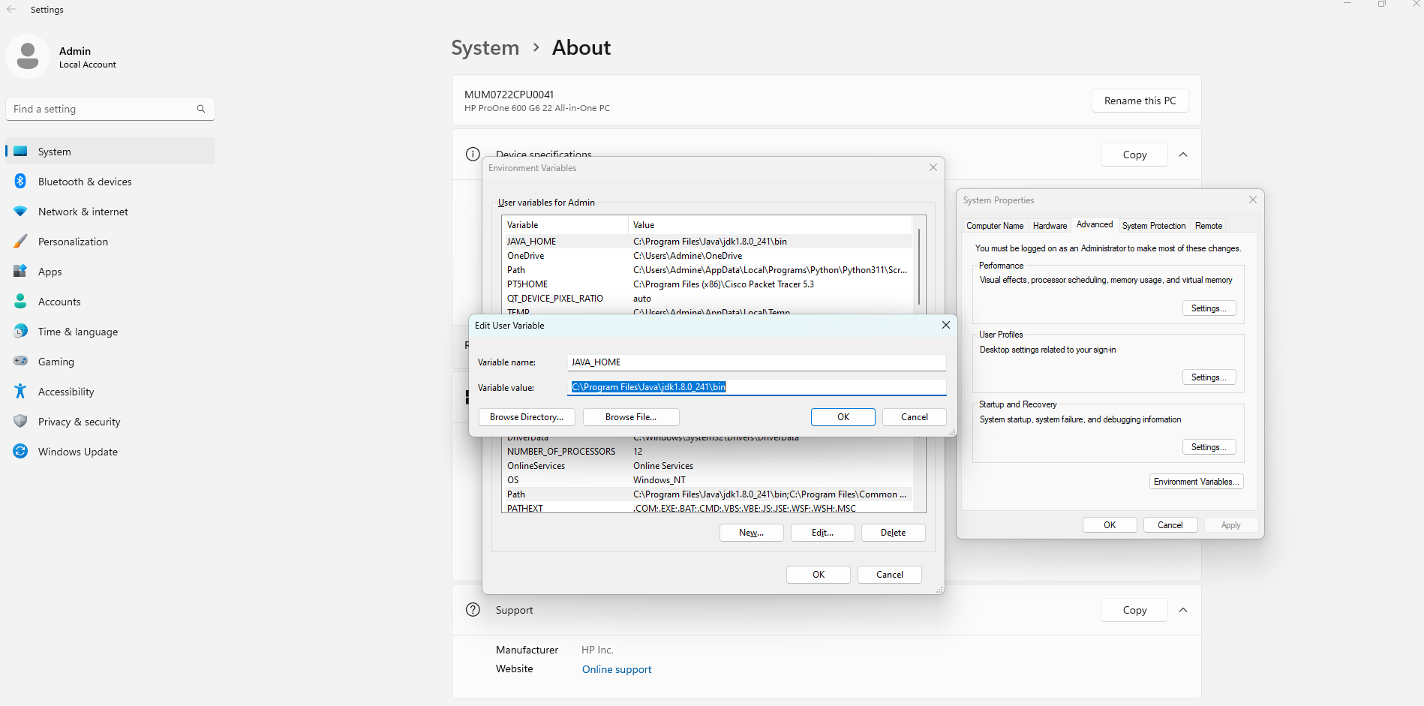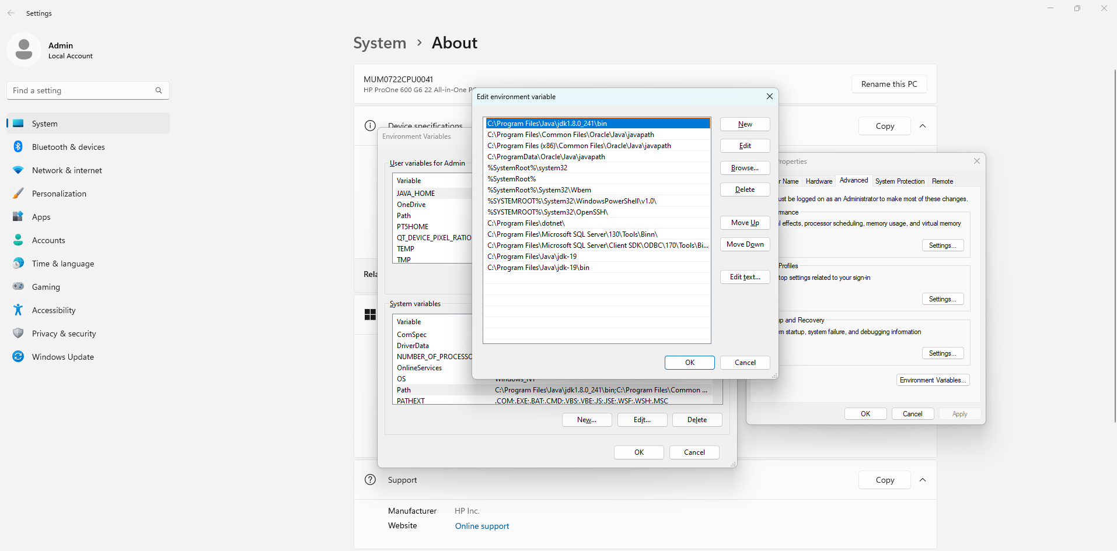

Download Hadoop

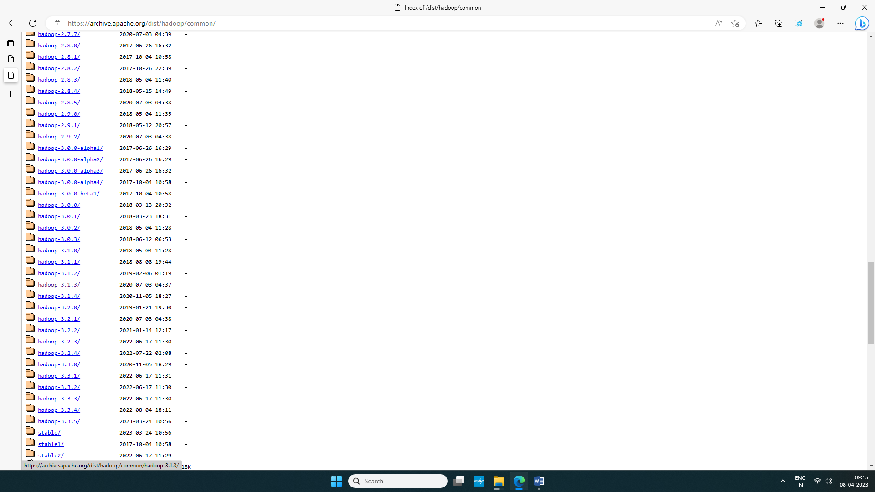

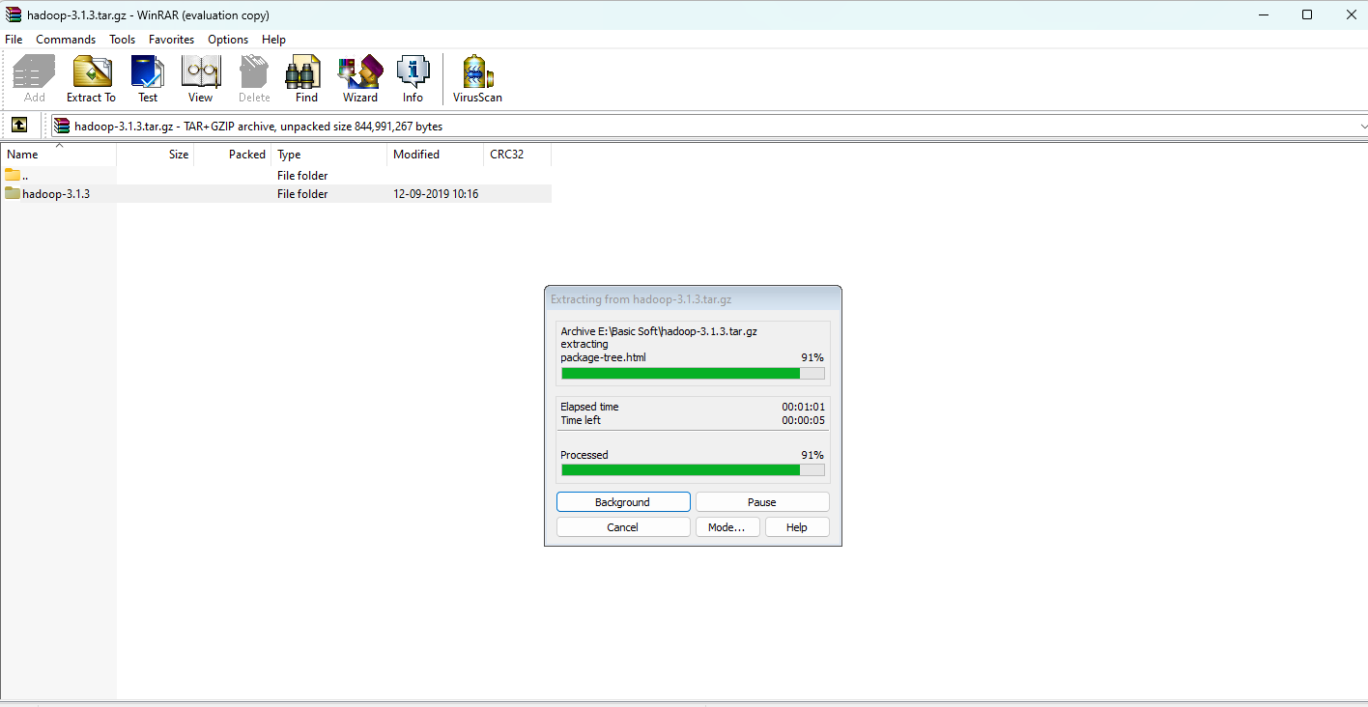

Extract it to E drive and rename hadoop-3.1.3 as Hadoop

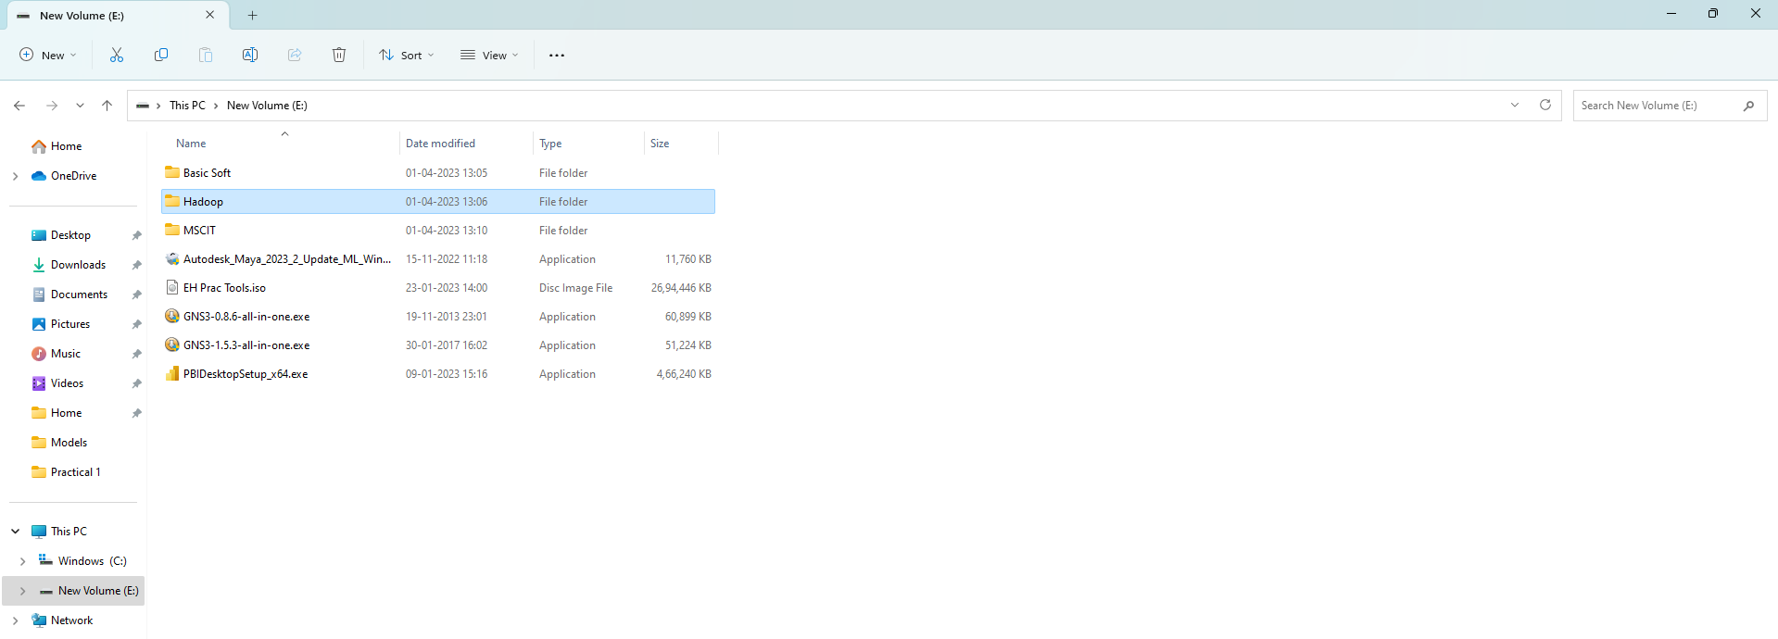

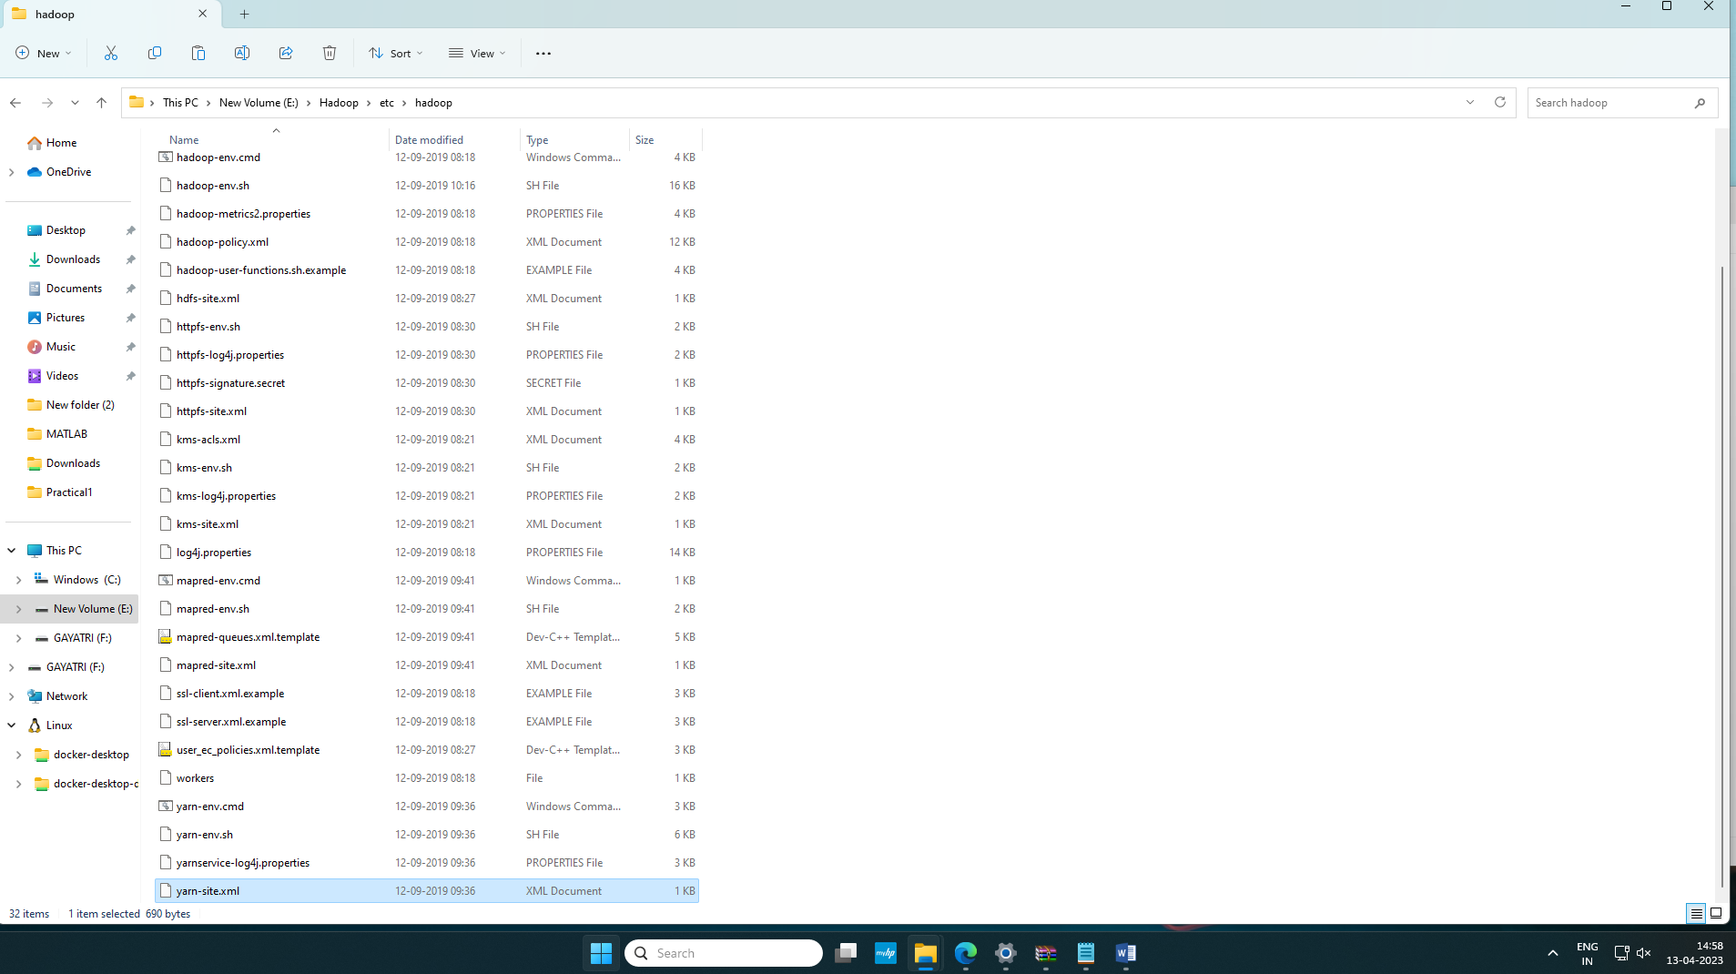

Go to E:\Hadoop\etc\hadoop in Hadoop and see if following xml files are there:

**core-site**

**httpfs-site**

**mapred-site**

**yarn-site**

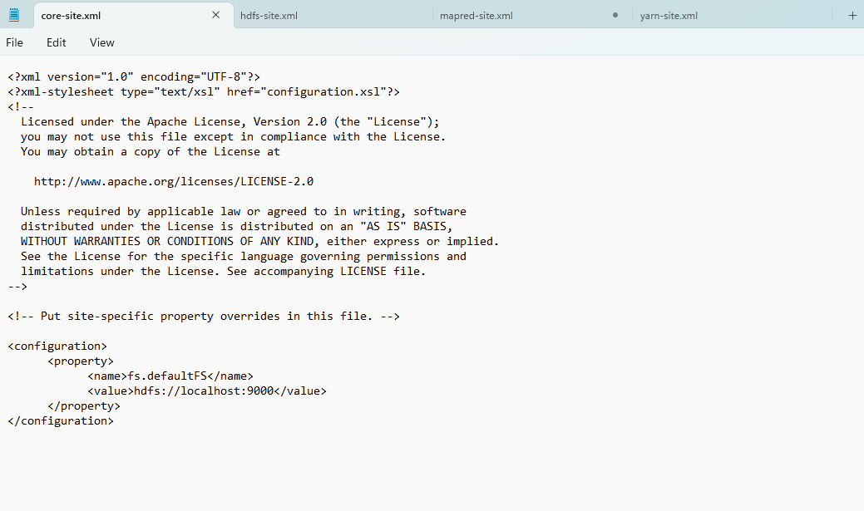

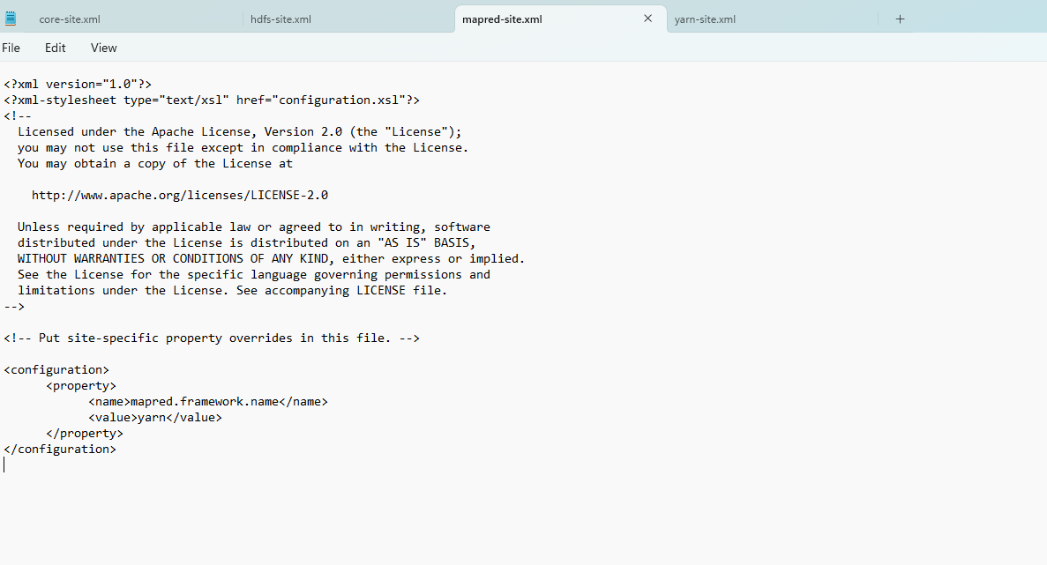

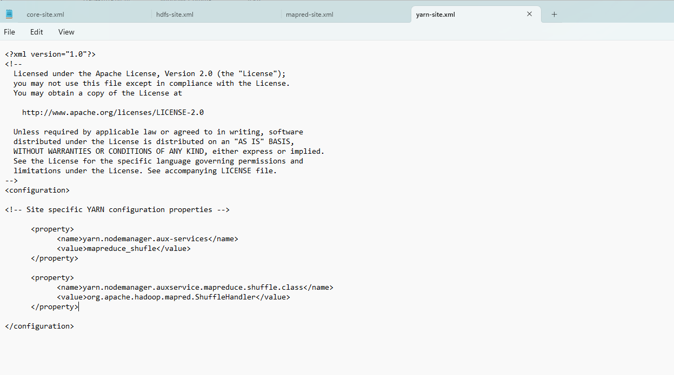

Create two folders under data folder:

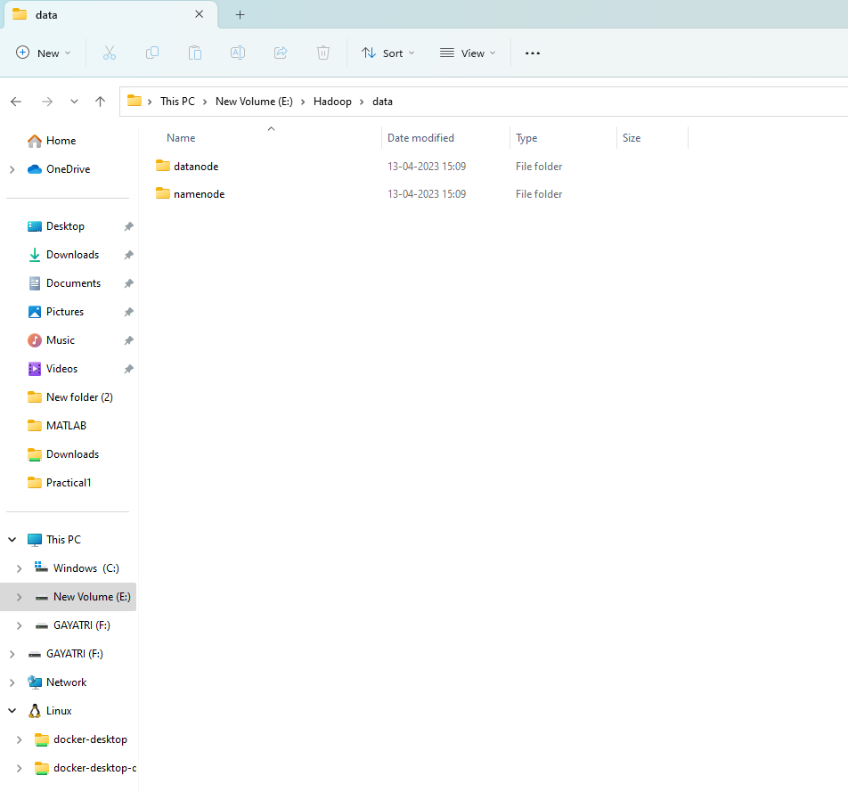

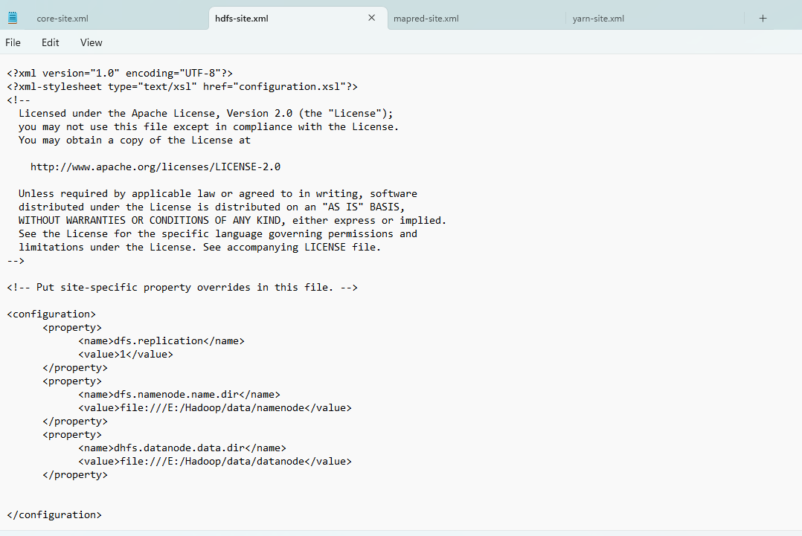

Save and close this 4 files

Open Hadoop-env.cmd file in notepad and set java home path

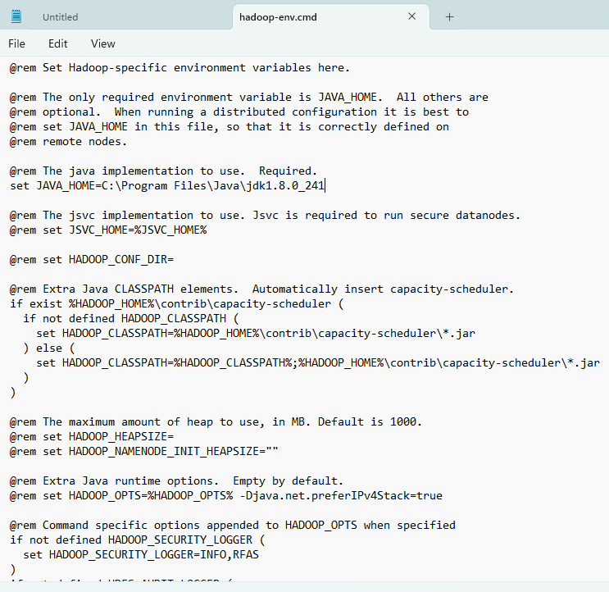

Set environment path for Hadoop in environment variable in user variable:

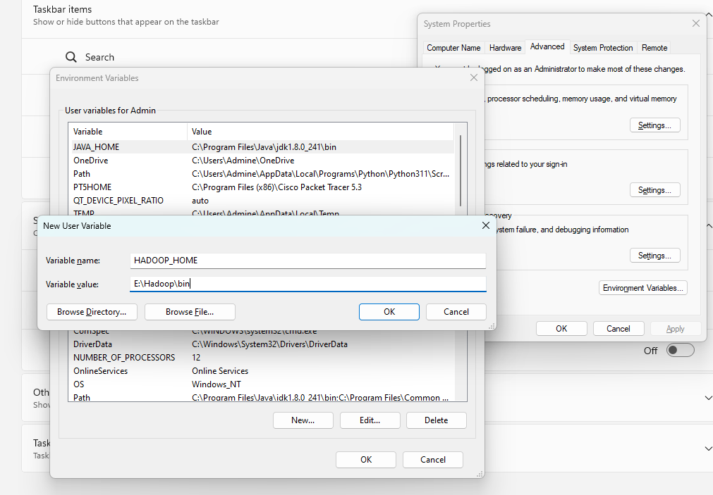

In system variables: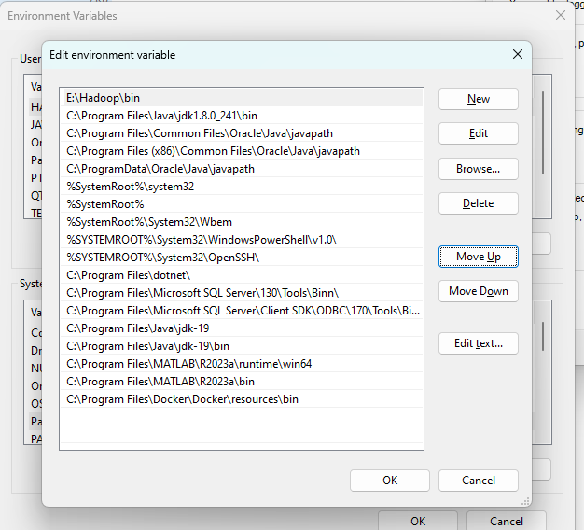

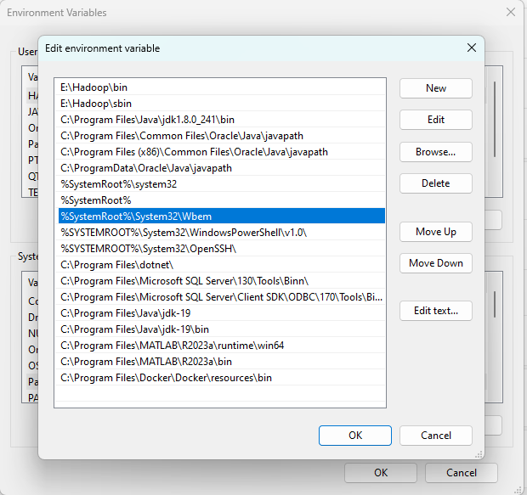

Extract HadoopConfiguration-FIXbin file and copy bin folder and replace Hadoop\bin folder with this folder

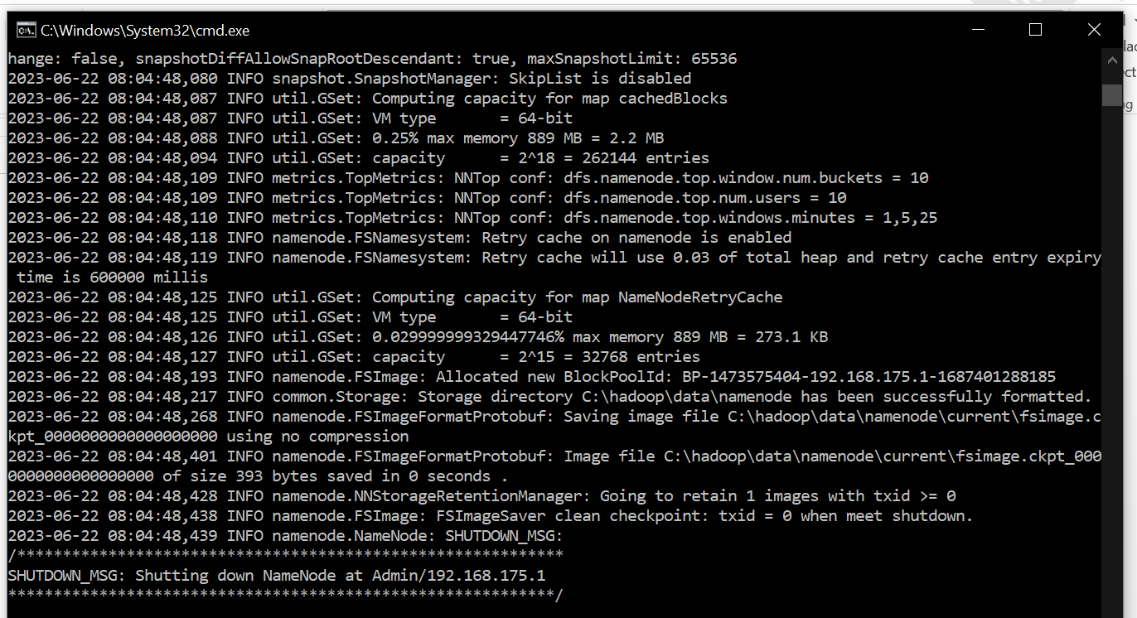

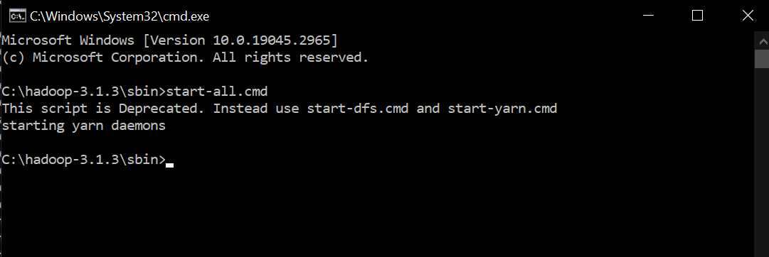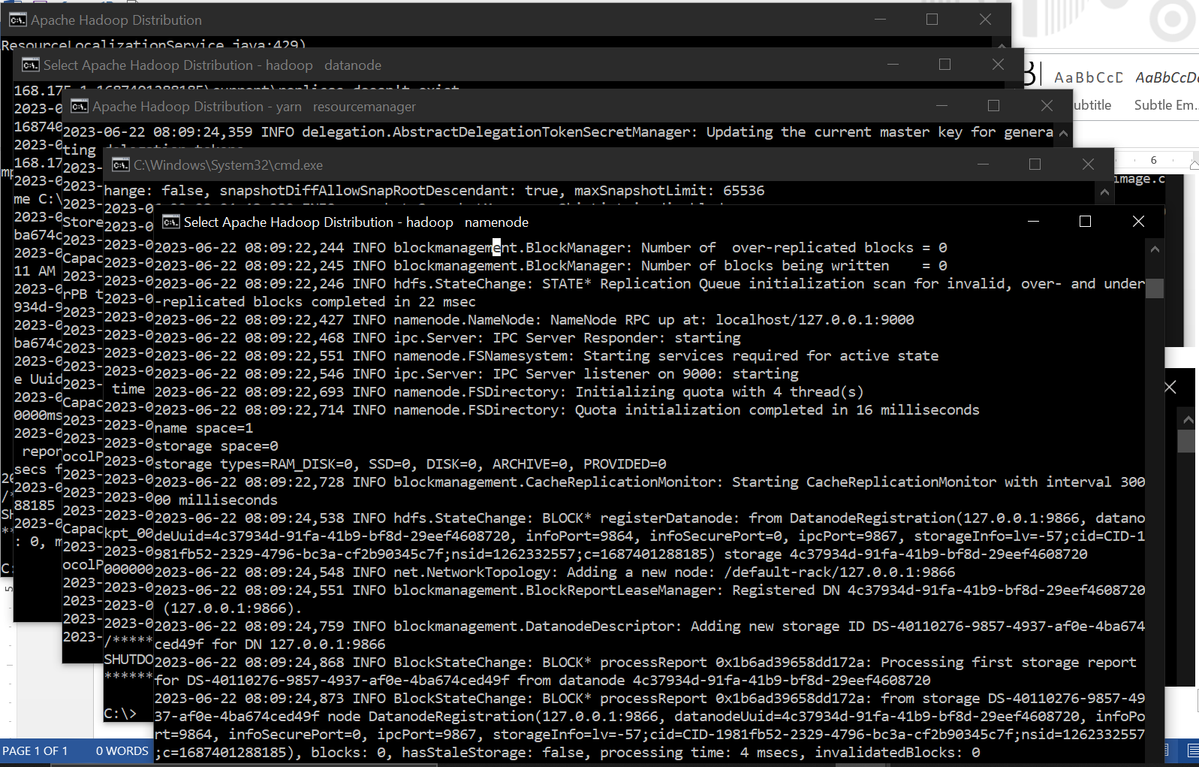

## **PRACTICAL 8**

AIM:Implement an application that stores big data in Hbase / MongoDB and manipulate it

using R / Python.

THEORY:

AIM:Implement an application that stores big data in Hbase / MongoDB and manipulate it

using R / Python.

THEORY:

MongoDB is an open-source and the leading NoSQL database. It is a document-oriented database that offers high performance, easy scalability, and high availability. It uses documents

and collections to organize data rather than relations. This makes it an ideal database management system for the storage of unstructured data.

MongoDB uses replica sets to ensure there is a high availability of data. Each replica set is made up of two or more replicas of data. This gives its users the ability to access their data at any time. The replica sets also create fault tolerance. MongoDB scales well to accommodate more data. It uses the sharing technique to scale horizontally and meet the changing storage needs of its users. MongoDB was developed to help developers unleash the power of data and software.

MongoDB is an unstructured database. It stores data in the form of documents. MongoDB is able to handle huge volumes of data very efficiently and is the most widely used NoSQL database as it offers rich query language and flexible and fast access to data.

**The Architecture of a MongoDB Database**

The information in MongoDB is stored in ***documents***. Here, a document is analogous to ***rows*** in structured databases.

* Each document is a collection of key-value pairs
* Each key-value pair is called a ***field***
* Every document has an ***_id*** field, which uniquely identifies the documents
* A document may also contain nested documents
* Documents may have a varying number of fields (they can be blank as well)

These documents are stored in a ***collection***. A collection is literally a collection of documents in MongoDB. This is analogous to ***tables*** in traditional databases.





Unlike traditional databases, the data is generally stored in a single collection in MongoDB, so

there is no concept of joins.

PyMongo is a Python library that enables us to connect with MongoDB. It allows us to perform

basic operations on the MongoDB database.

Python is chosen to interact with MongoDB because it is one of the most commonly used and

considerably powerful languages for data science. PyMongo allows us to retrieve the data with

dictionary-like syntax. Additionally, PyMongo’s rich documentation is always standing there

with a helping hand.

**Steps of the installation:**

**Step 1: Download MongoDB**

**Step 2: Install MongoDB**

**Step 3: Verify MongoDB Installation**

**Step 4: Install MongoDB Python on Windows**

**Step 5: Verify MongoDB Python Connection**

**Step 1: Download MongoDB**

Go to official website:

https://www.mongodb.com/try/download/community

Download MongoDB Community server.

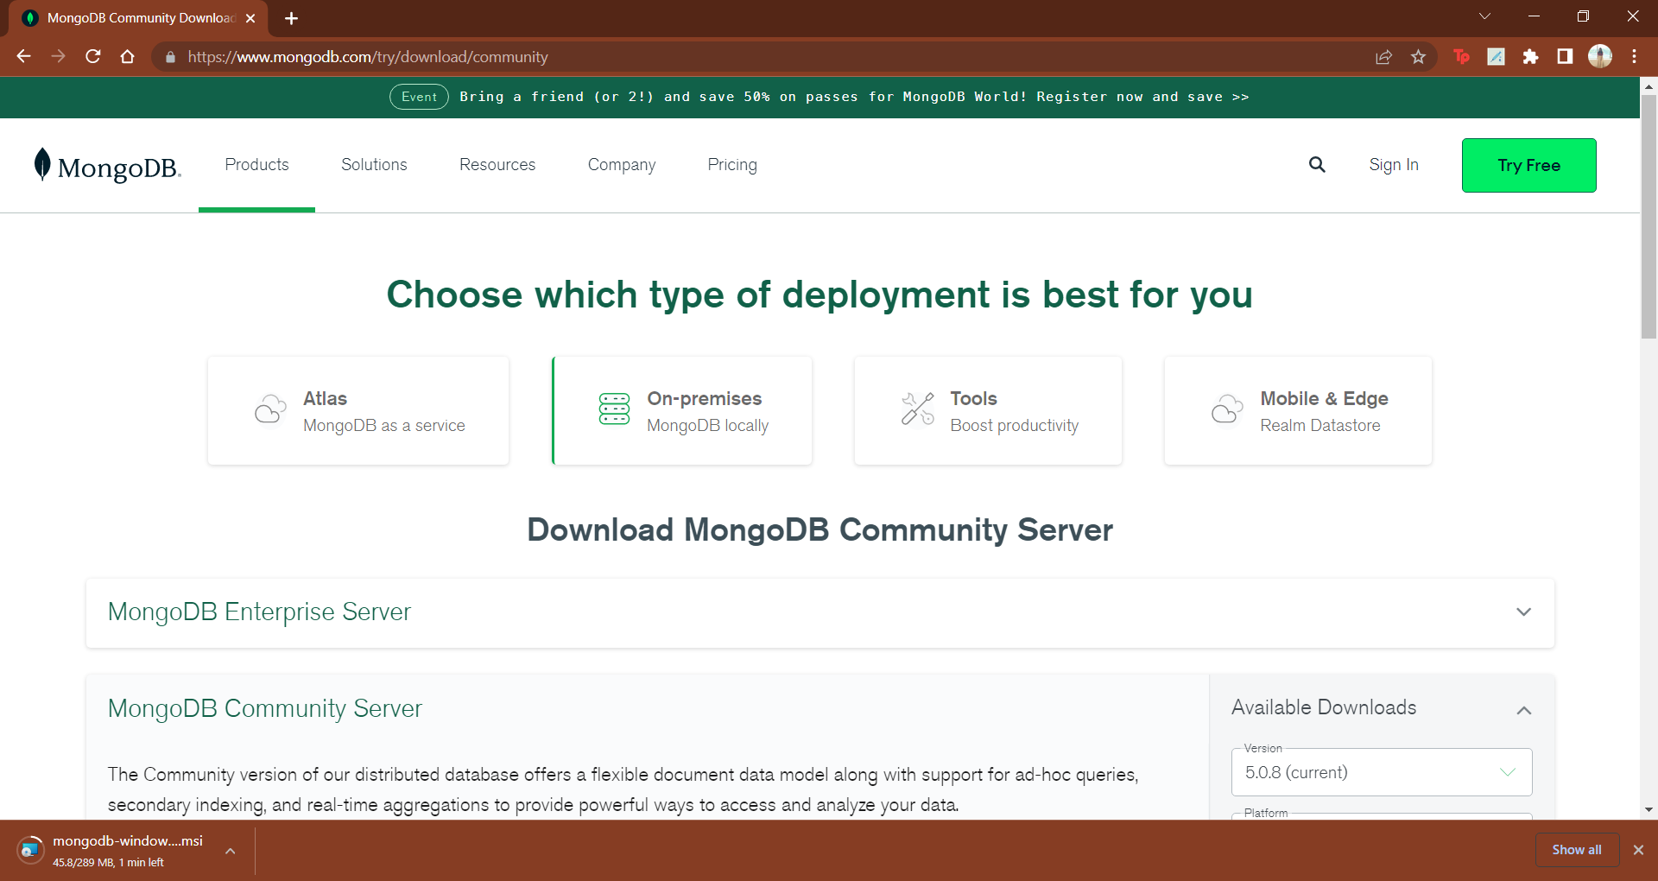

Click on download

**Step 2: Install MongoDB**

It will download msi file. Click on it and Start the installation.





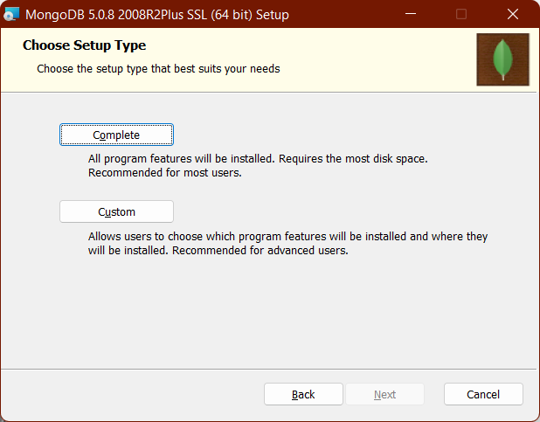



Keep all these setting as it is. Click on next.



Click on next

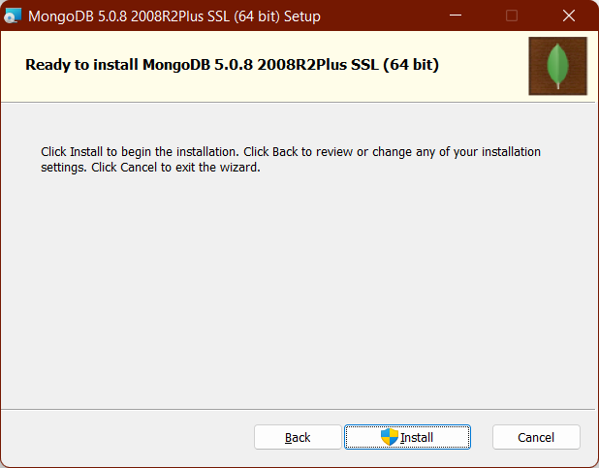

Click on Install.

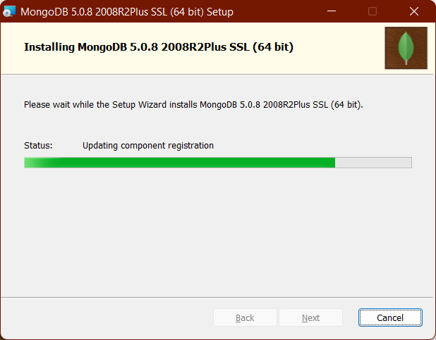



**Step 3: Verify MongoDB Installation**

Now go to

C:\Program Files\MongoDB\Server\5.0\bin

Start command prompt from this location

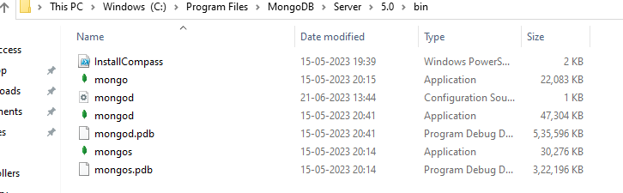

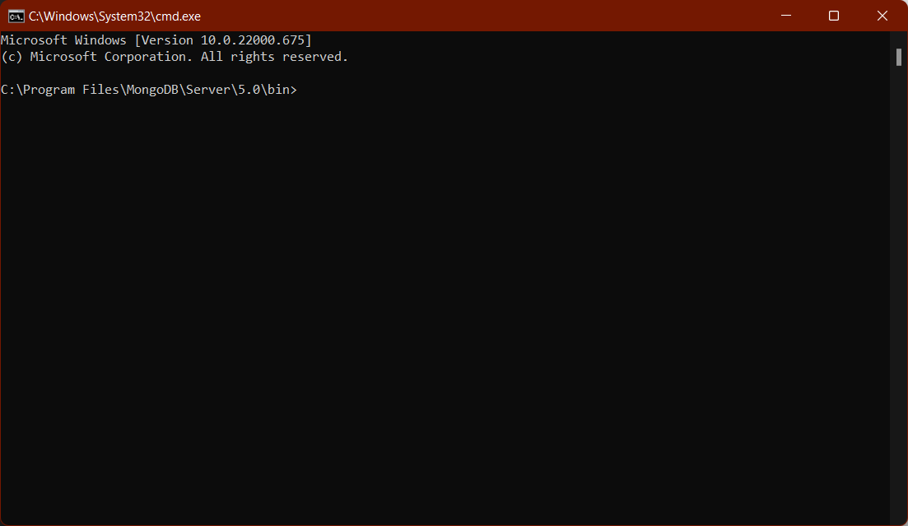

To start mongo db server

Enter **mongod** command

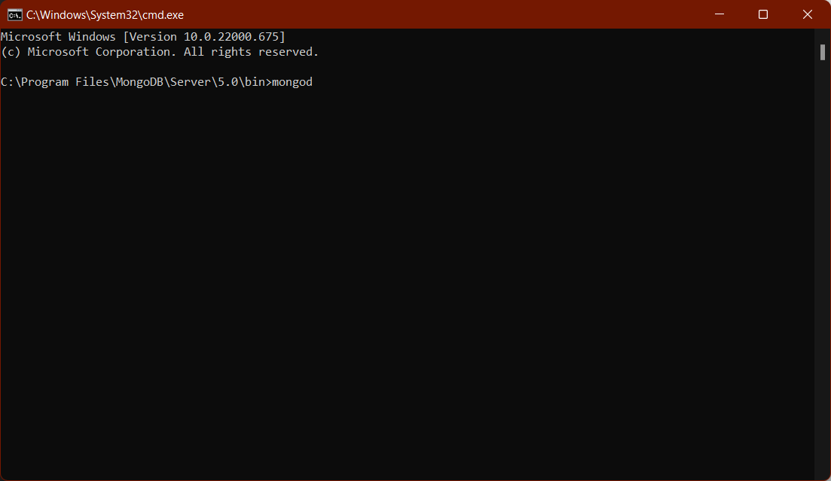

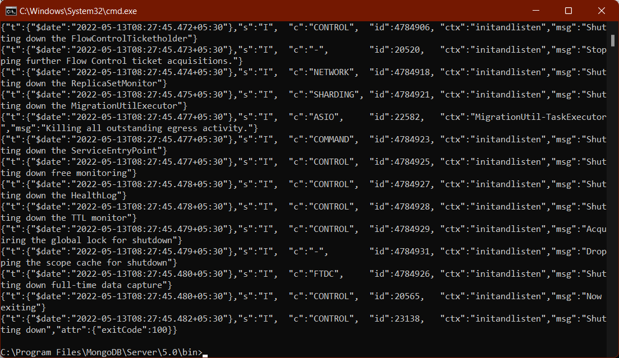

It says c:\data\db directory not found

So, create this directory structure: c:\data\db

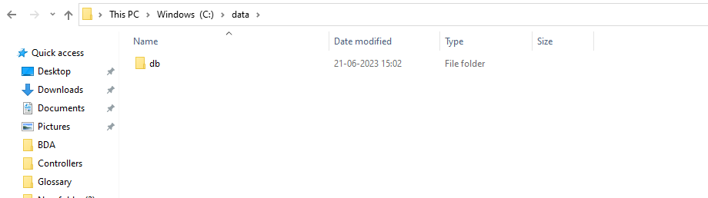

Run the above command mongod once again.

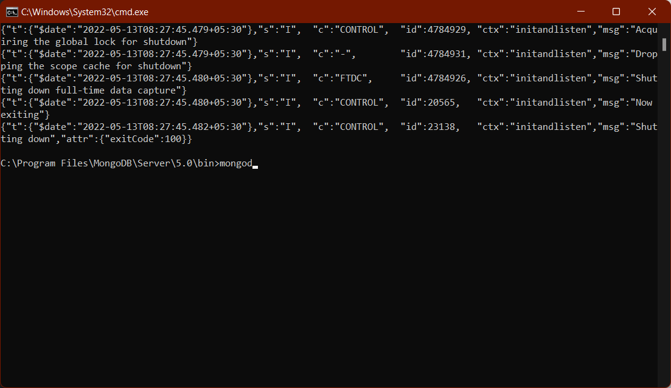

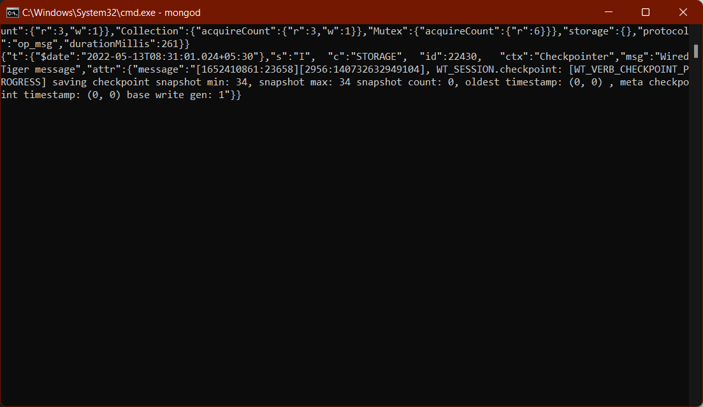

Mongo daemon is started now

To open the mongo shell

Go to

C:\Program Files\MongoDB\Server\5.0\bin

Start command prompt from this location

Fire the command: mongo

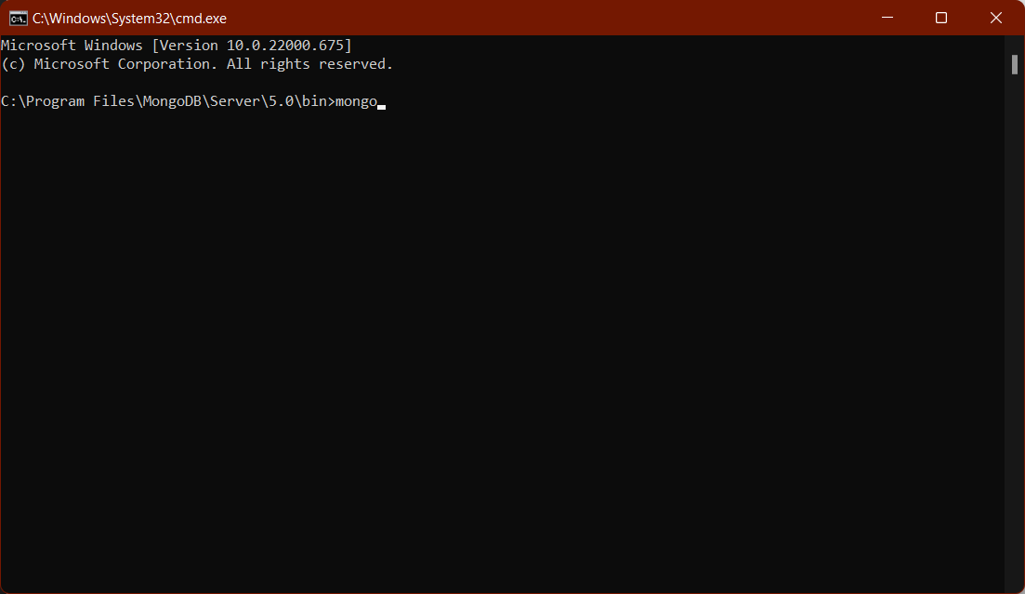

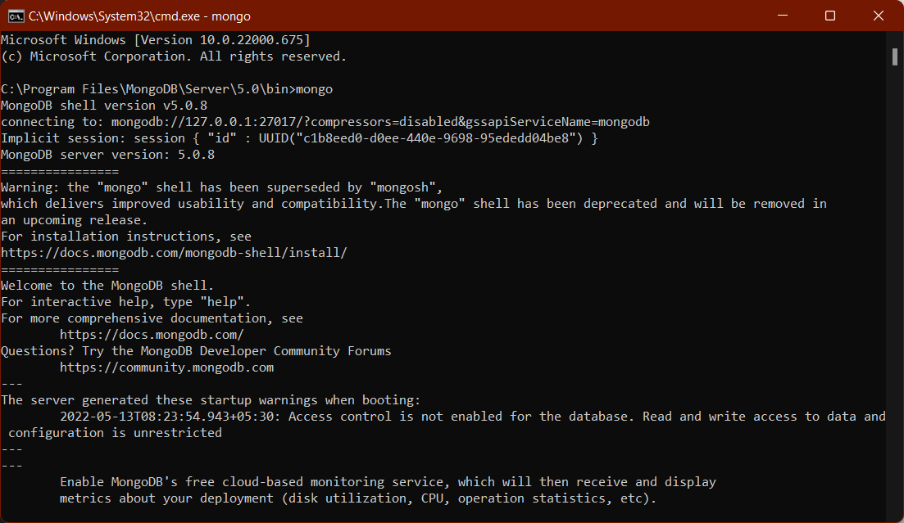

Mongo shell is started

To see all the default databases, fire this command in mongodb shell:

>show dbs

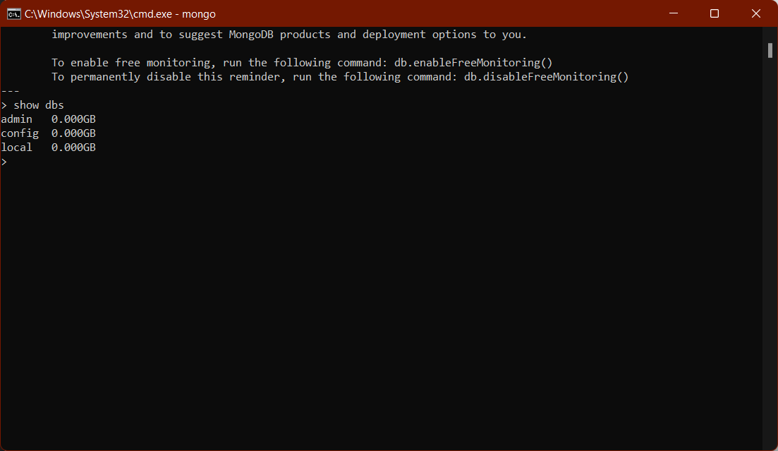

To create new database named my_database:

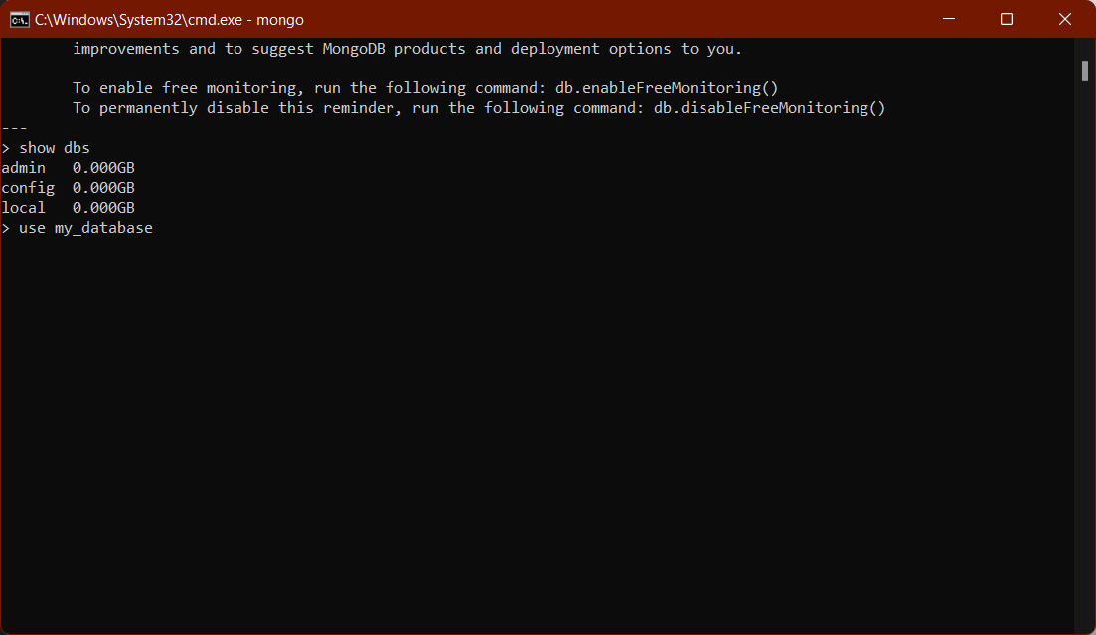

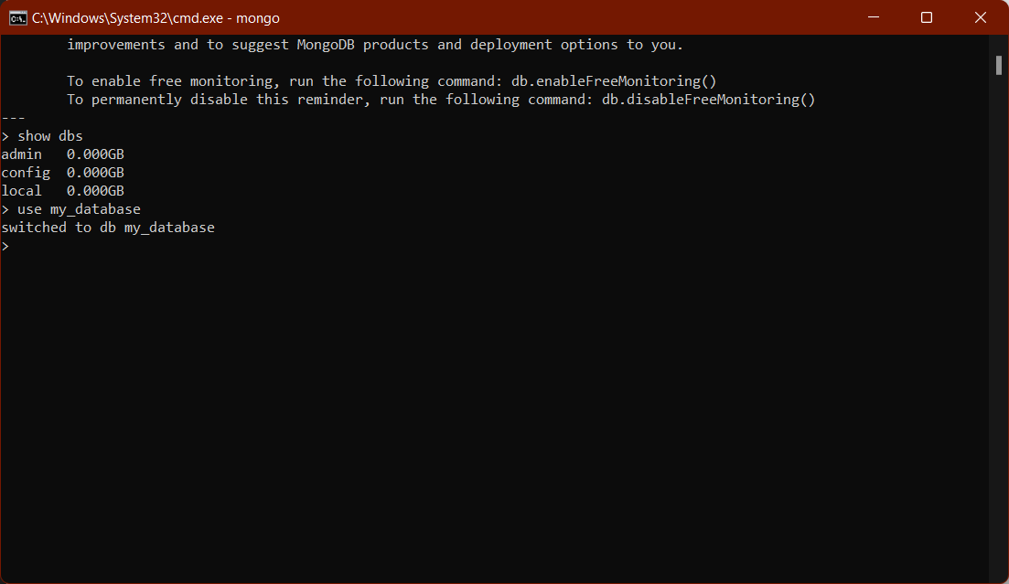

To create collection in the database and insert json values into it:

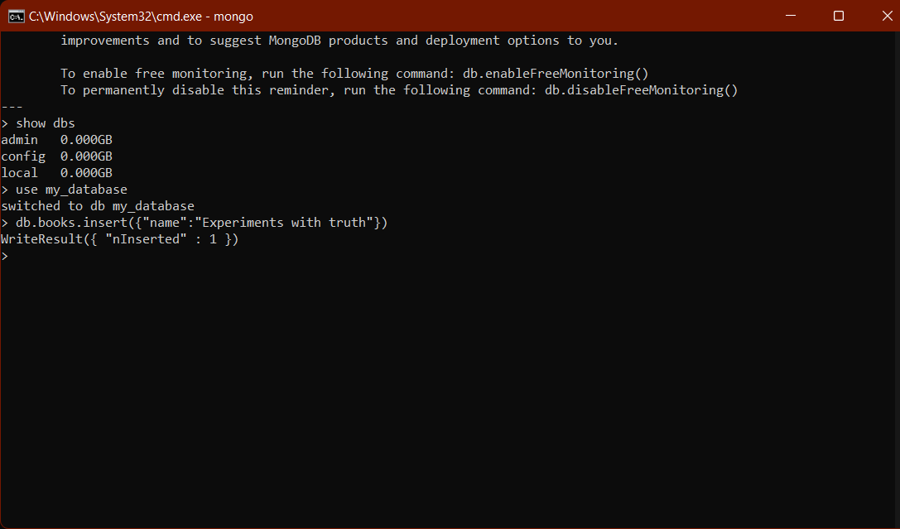

To see entered collection:

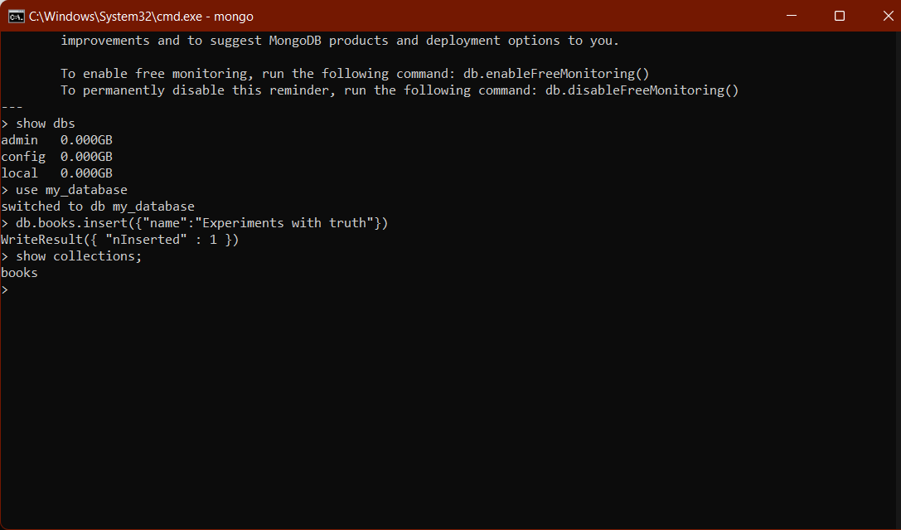

To see all the documents in the collection:

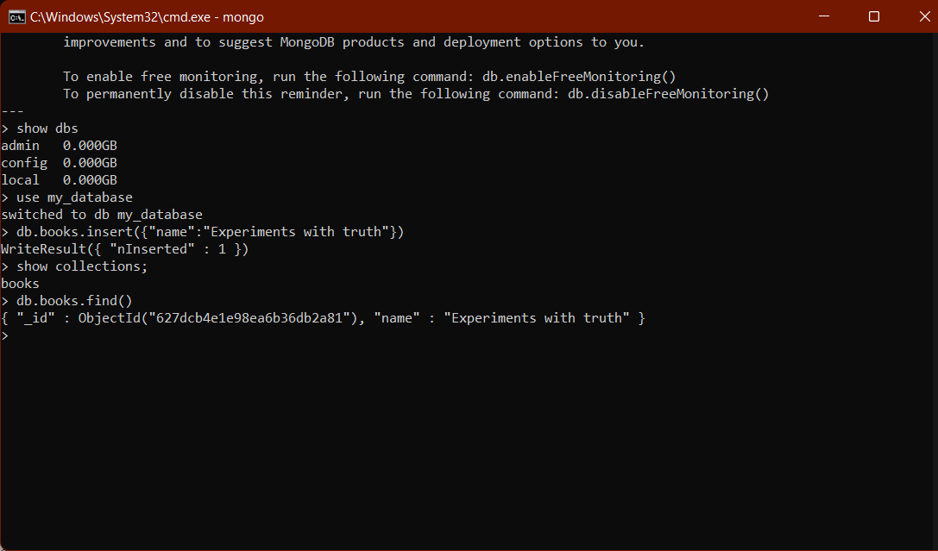

To set path of MongoDB server and shell

Copy in clipboard: C:\Program Files\MongoDB\Server\5.0\bin

Go to environment variables

Add mongodb path to system path variable

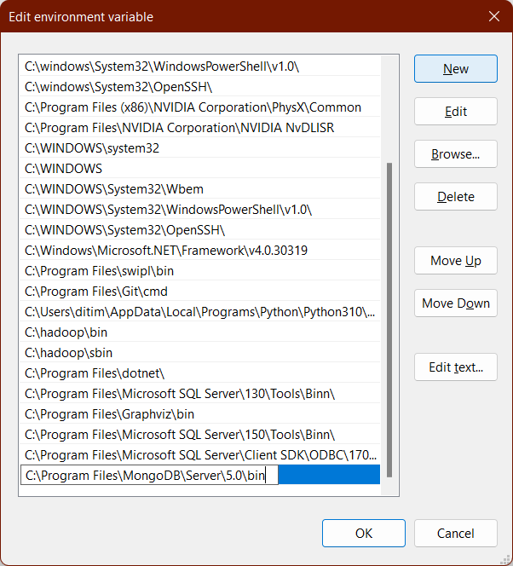

Paste the path: C:\Program Files\MongoDB\Server\5.0\bin

Click on ok and come out of environment variables.

Run mongod and mongo command from command prompt once again from anywhere, it will

start mongo server and mongo shell

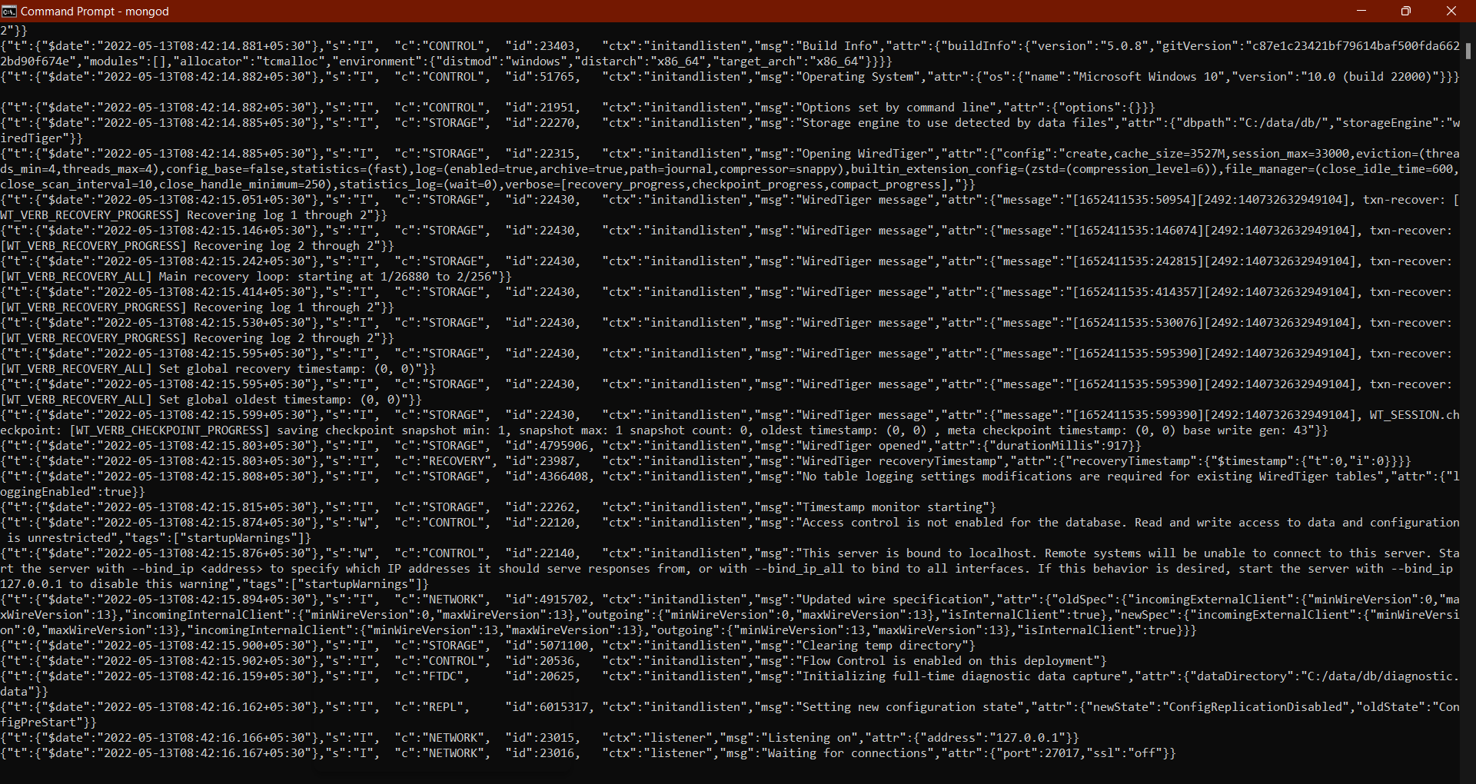

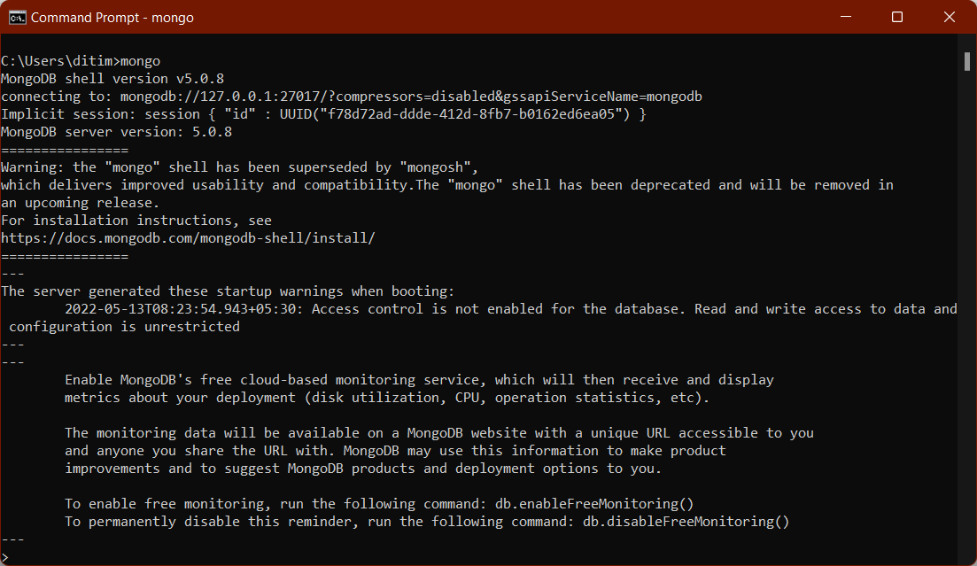

To get the effect of running mongod as service, Restart your windows operating system.

After Restarting the machine, to check mongod service is running automatically:

Open command prompt

Give mongo command without running mongod command in another terminal.

It will start mongod server.

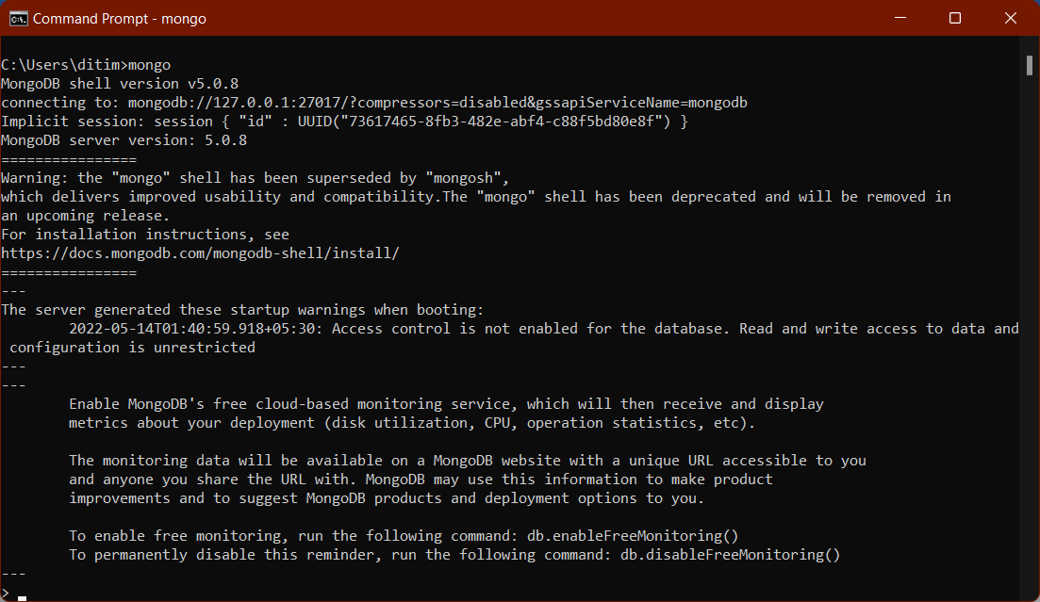

**Step 4: Install MongoDB Python on Windows**



We will be performing a few key basic operations on a MongoDB database in Python using the PyMongo library.

Install package to use MongoDB

To install this package with conda run:

conda install -c anaconda pymongo

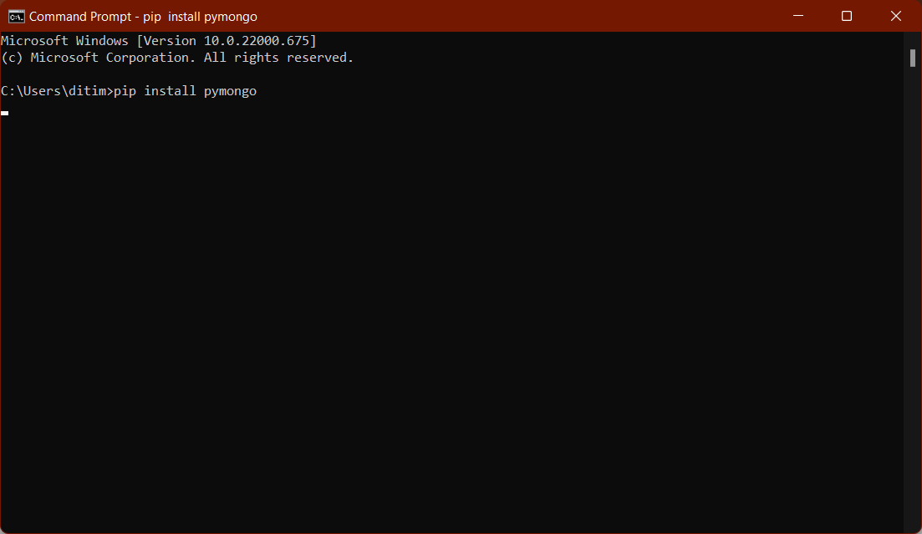

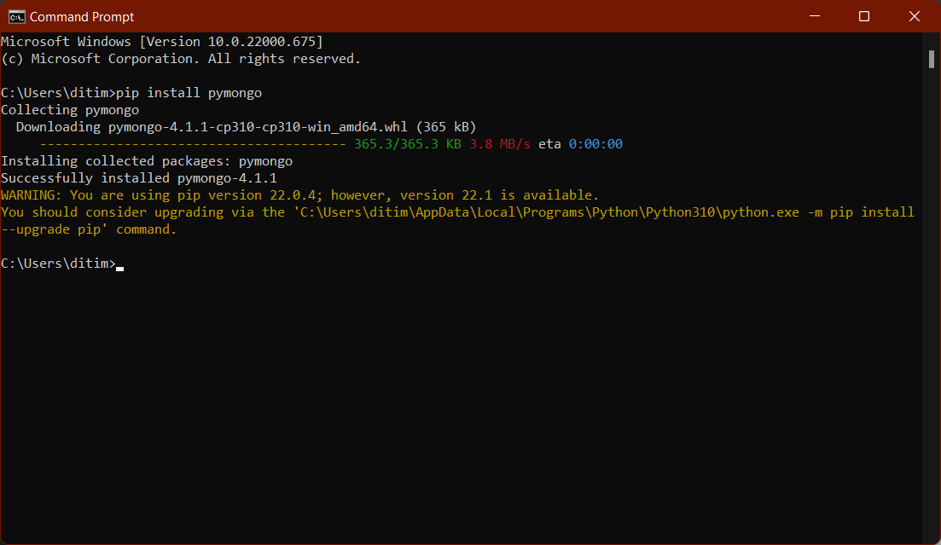

**Step 5: Verify MongoDB Python Connection**

To retrieve the data from a MongoDB database, we will first connect to it. Write and execute the below code in your Spyder.

import pymongo

mongo_uri = "mongodb://localhost:27017/"

client = pymongo.MongoClient(mongo_uri)

Let’s see the available databases:

print(client.list_database_names())

We will use the my_database database for our purpose. Let’s set the cursor to the same database:

db = client.my_database

connect to analysis database

The list_collection_names command shows the names of all the available collections:

print(db.list_collection_names())

Let’s see the number of books we have. We will connect to the customers collection and then print the number of documents available in that collection:

table=db.books

print(table.count_documents({}) ) #gives the number of documents in the table

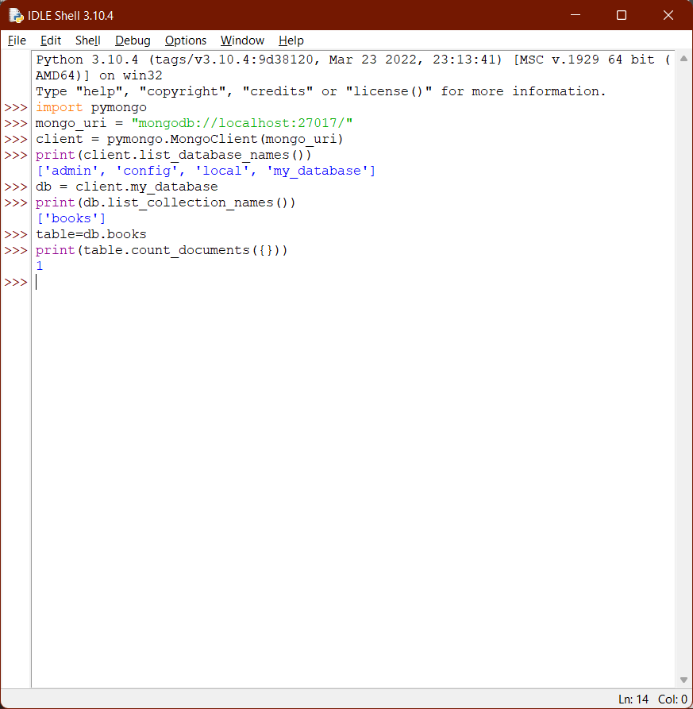

**Code and output:**

**1. Verifying the MongoDB connectivity with python**

Open Anaconda and then start spyder software to run following python code.

import pymongo

mongo_uri = "mongodb://localhost:27017/"

client = pymongo.MongoClient(mongo_uri)

print(client.list_database_names())

db = client.my_database

print(db.list_collection_names())

table=db.books

print(table.count_documents({}))

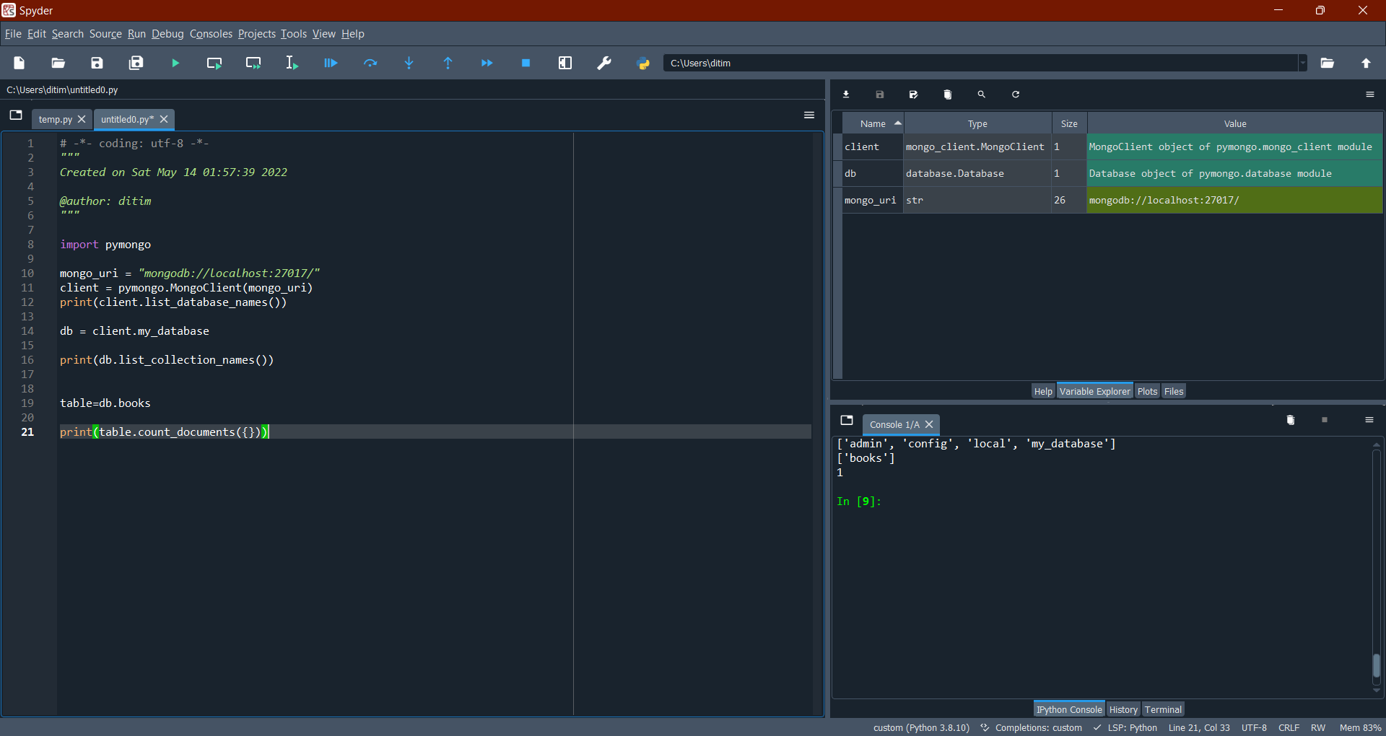

**2. Creating a new collection**

import pymongo

mongo_uri = "mongodb://localhost:27017/"

client = pymongo.MongoClient(mongo_uri)

# connecting to the existing database

mydb = client["my_database"]

# Creating a collection :

mycol = mydb["customers"]

print(mydb.list_collection_names())

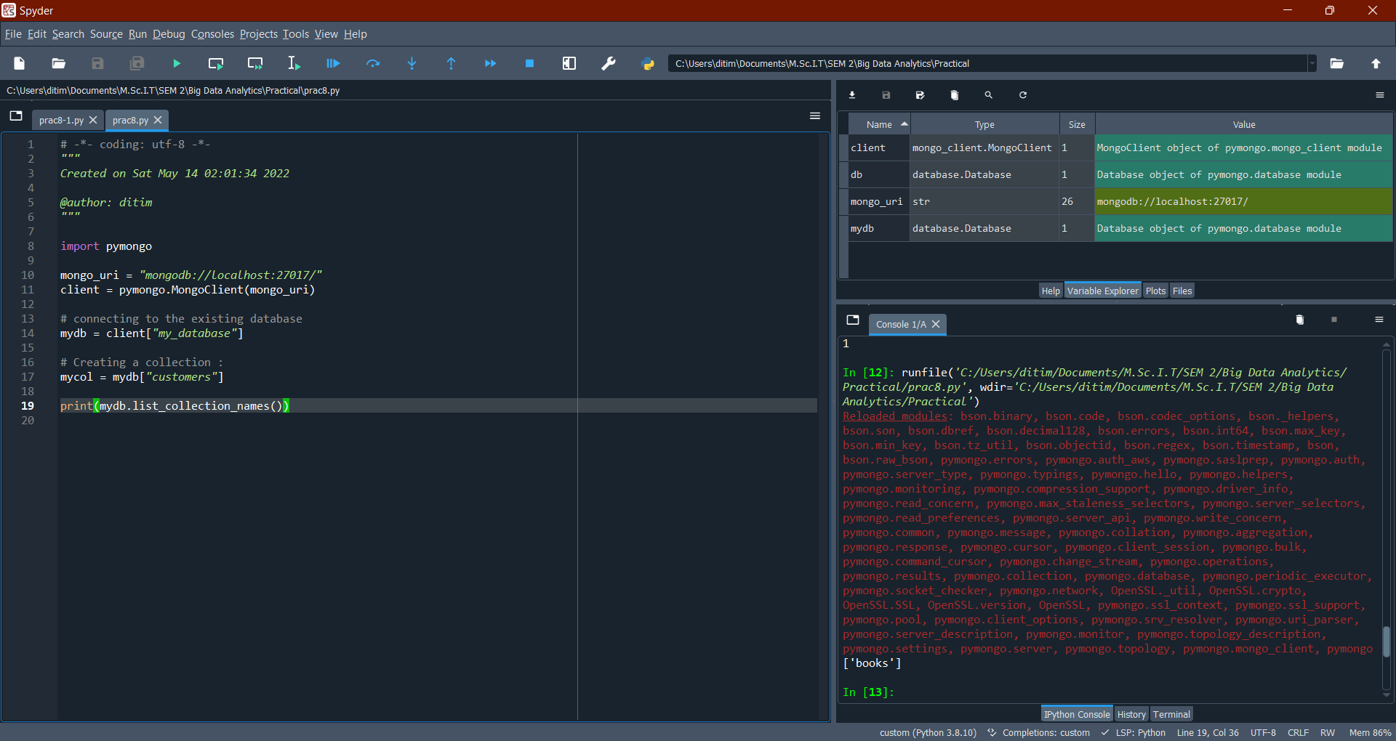

**3. Inserting the documents**

To insert a record, or document as it is called in MongoDB, into a collection, we use the insert_one() method. The first parameter of the **insert_one()** method is a dictionary containing the name(s) and value(s) of each field in the document you want to insert.

# insert new document

mydict = {"name":"John", "address":"Highway37"}

x = mycol.insert_one(mydict)

# print list of collections

print(mydb.list_collection_names())

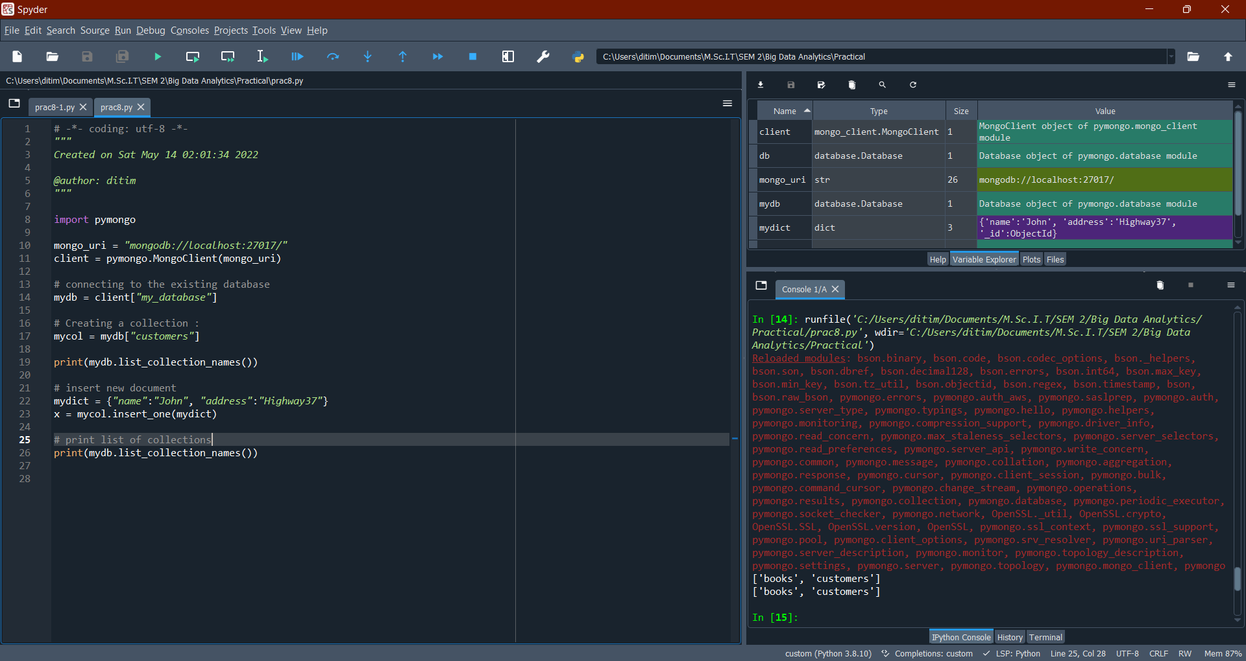

Go to mongodb client and fire these commands to view inserted records:

> show dbs

admin 0.000GB

config 0.000GB

local 0.000GB

my_database 0.000GB

> use my_database

switched to db my_database

> show collections;

books

customers

> db.customers.find()

{ "_id" : ObjectId("627ec15e5b5a2952d3035b2b"), "name" : "John", "address" : "Highway37" }

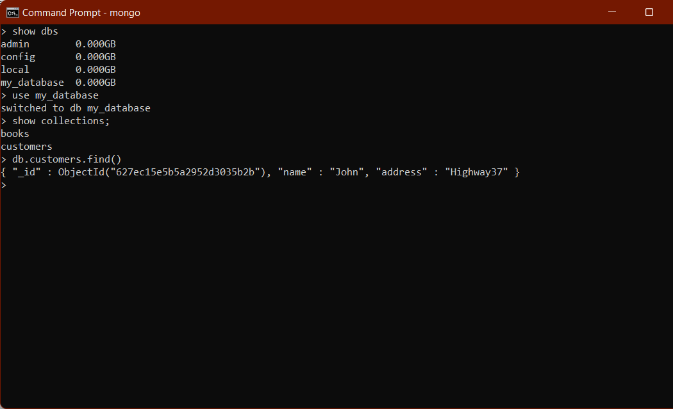

**Inserting multiple records:**

To insert multiple documents into a collection in MongoDB, we use the insert_many() method. The first parameter of the insert_many() method is a list containing dictionaries with the data you want to insert:

#inserting multiple documents

mylist = [{"name":"Amy","address":"Applest652"},

{"name":"Hannah","address":"Mountain21"},

{"name":"Michael","address":"Valley345"},

{"name":"Sandy","address":"Oceanblvd2"},

{"name":"Betty","address":"GreenGrass1"},

{"name":"Richard","address":"Skyst331"}]

x = mycol.insert_many(mylist)

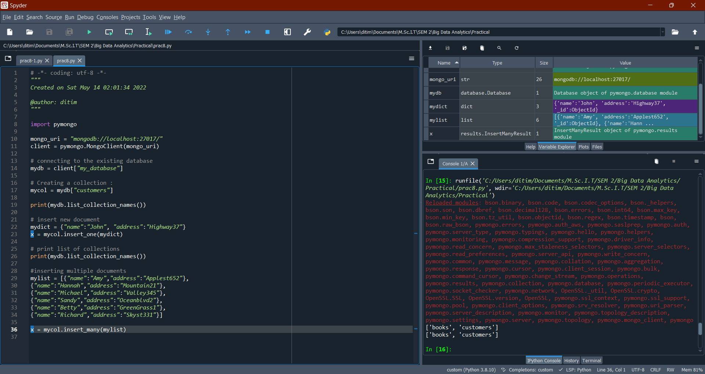

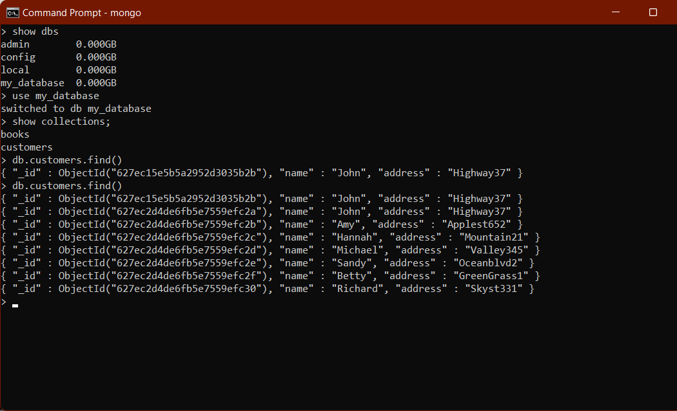

**4. Updating the documents**

You can update a record, or document as it is called in MongoDB, by using the update_one() method.

The first parameter of the update_one() method is a query object defining which document to update.

myquery = { "address": "Valley 345" }

newvalues = { "$set": { "address": "Canyon 123" } }

mycol.update_one(myquery, newvalues)

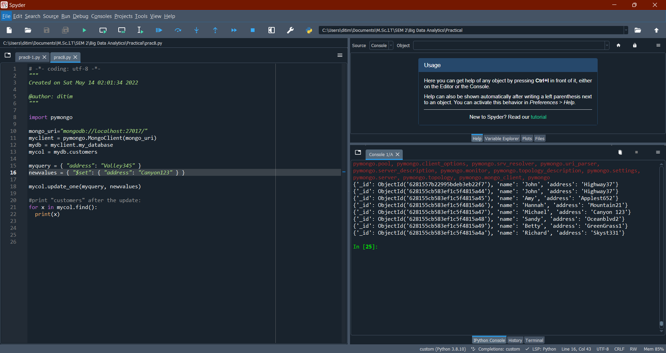

To update all documents that meets the criteria of the query, use the update_many() method.

myquery = { "address": { "$regex": "^S" } }

newvalues = { "$set": { "name": "Minnie" } }

x = mycol.update_many(myquery, newvalues)

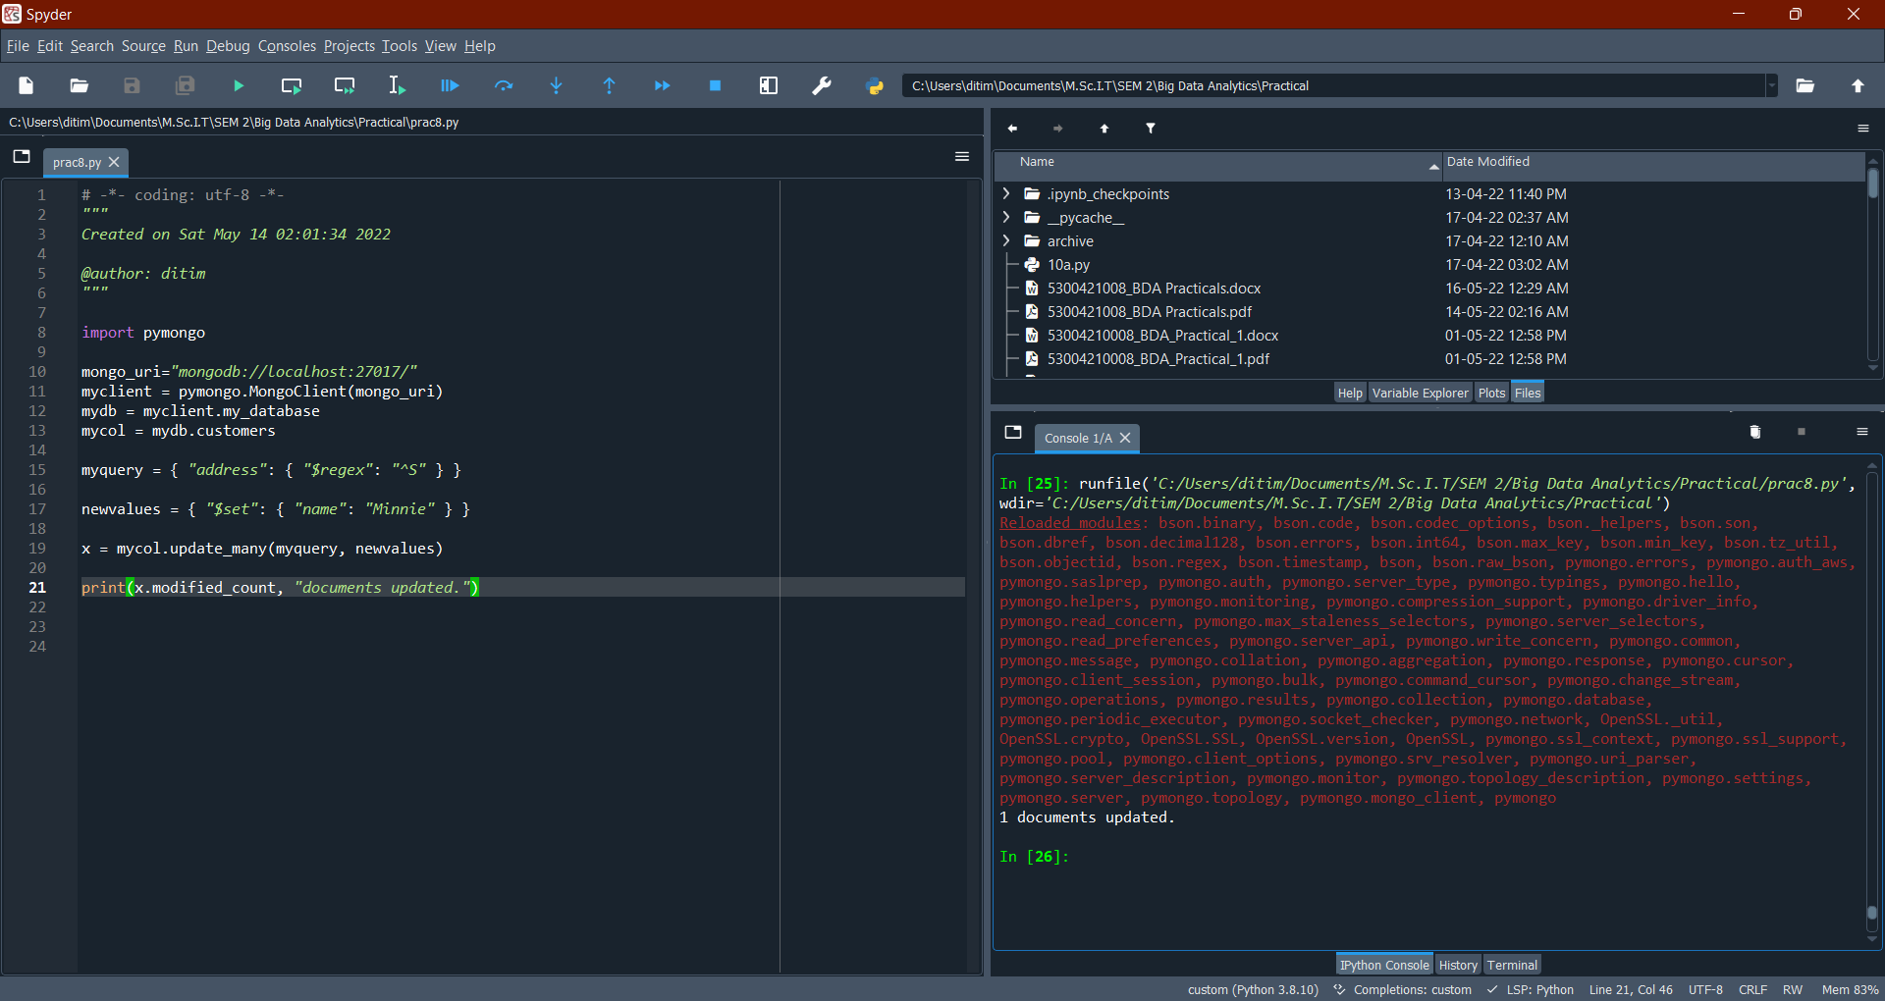

**5. Deleting the documents**

To delete one document, we use the delete_one() method.The first parameter of the delete_one() method is a query object defining which document to delete.

myquery = { "address": "Mountain 21" }

mycol.delete_one(myquery)

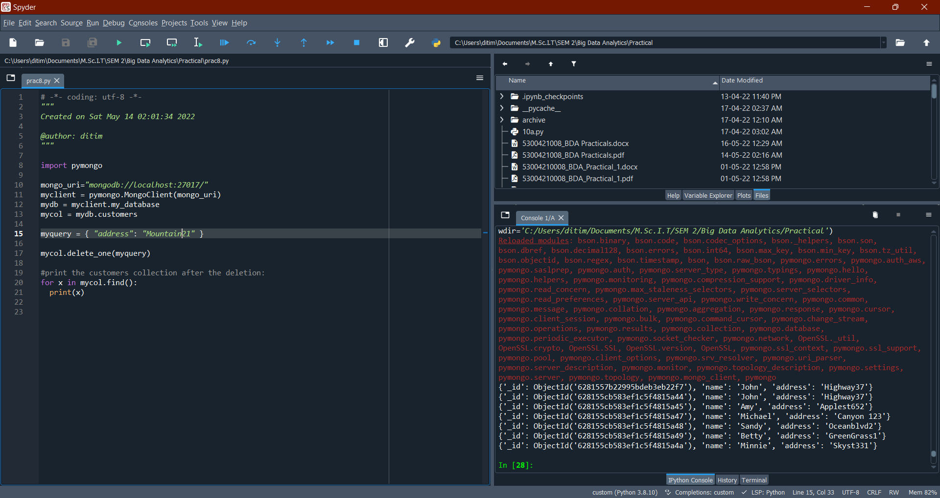

To delete more than one document, use the delete_many() method.The first parameter of the delete_many() method is a query object defining which documents to delete.

myquery = { "address": {"$regex": "^S"} }

x = mycol.delete_many(myquery)

